

ZULQUER

NAIN

ALI

SALES

&

MARKETING

PROFESSIONAL

Characterized as flexible, result oriented and analytical individual possessing superior

presentation, time

management

and

organization

skills;

true

team

leader,

mentor

and

a

motivator

with

fi

ne

-

tuned

analytical

&

troubleshooting

skills



Zulquerali.31dec@gmail.com

+91 +91

8800997880 Calling 7320090510 Whatsapp

Hs No: R7 Jangpura, Bhogal Market, New Delhi 110014

31

December,

1996

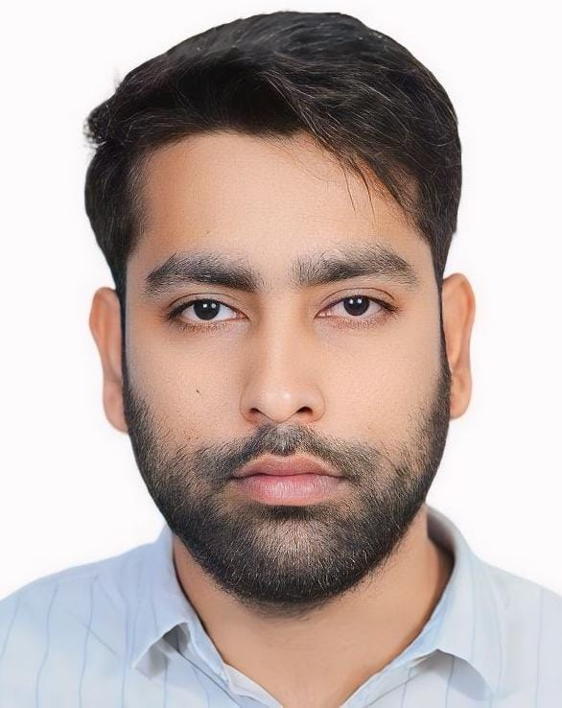

# WORK EXPERIENCE

* **Sales & Marketing Executive**

Vogue Packing Mat. Equip. Tr., UAE

09/2024 – 10/2024

Led sales and marketing efforts for packaging materials, expanding the client base and boosting revenue.

Developed and executed marketing strategies to enhance brand visibility and customer engagement.

Negotiated and closed deals with key clients, strengthening business relationships.

Gained valuable international market exposure, adapting to UAE’s competitive sales environment.

Returned to India seeking a more aligned role with growth opportunities.

# Team Leader

Bharti Airtel Limited

11/2021 ­– 09/2024 Gurgaon - Delhi NCR

*National Escalation Specialist*: *Escalating any inquiries that need further investigation in accordance with Helpdesk Escalation Procedure -Monitor, log and respond to incoming queries via email Investigate low priority issues and escalate in accordance with Helpdesk procedures .*

* **Associate Sales Consultant**

PolicyBazaar.com

02/2019 – 05/2021 Gurgaon - Delhi NCR

*Product Knowledge: Gaining a deep understanding of the insurance product and services offered by the company, including different types of insurance policies such as health insurance, life insurance, auto insurance, etc. Sales Techniques: Learning and honing your sales skills, including effective communication, objection handling, and relationship Building with Customers.*

* **Junior Accountant Cum Client Relationship Manager**

Noor Hashmi And Co.

05/2017 – 01/2019 Uttar Pradesh - Kanpur

*Problem-Solving: Collaborated with internal and cross-functional teams to ensure the smooth delivery of financial services to clients. This included working closely with senior accountants, auditors, and tax professionals to deliver accurate and timely financial reports, balance sheets, and tax filings. I coordinated efforts to manage payroll processing and ensure compliance with local tax regulations. Additionally, I facilitated communication between clients and our internal teams to ensure that client requirements were met efficiently. This collaboration helped streamline processes, resolve issues promptly, and maintain strong, long-term client relationships while meeting all deadlines.*

# CERTIFICATES

* Layman’s Economics, School of Humanities and Social Science

*Chhatrapati Shahu Ji Maharaj University, Kanpur.*

* Stock Market

*Zerodha Varsity*

# EDUCATION

* **MBA – Business Economics.**

*Chhatrapati Shahu Ji Maharaj University, Kanpur*

*2022*

* **B.com**

*Halim Muslim P.G. College, Kanpur*

*2020*

* **Intermidiate – Commerce**

*Kabir Memorial College, Jamshedpur*

*2016*

# SKILLS

* Excel +CCA
* Tally Prime
* Sales & Marketing
* Customer Service
* Quality Assurance
* Adaptability and Quick learner.
* Good Team Player
* Soft Communication Skills.

# CLUBS & COMMUNITIES

➢ **Coordinator – Recruitment Drive**

*Chhatrapati Shahu Ji Maharaj University, Kanpur*

*2022*

# PROJECT INTERNSHIPS

* CodeFlik Technology (08/2021)

Business Development Intern.

* Amazon (09/2021)

Business Development Intern.

# LANGUAGES

* English

*Professional Working Proficiency*

* Hindi

*Native or Bilingual Proficiency*

* Urdu

*Native or Bilingual Proficiency*

# INTERESTS

* Sales & Marketing
* Stock Market
* Cricket & Athletics
* Networking

# DETAIL OF PASSPORT

PASSPORT NO. : V9441325

PLACE OF ISSUE: PATNA

DATE OF ISSUE: 19-04-2022

DATE OF EXPIRY: 18-04-2032

xxxxxxxxxxxxx