CURRICULUM -VITAE

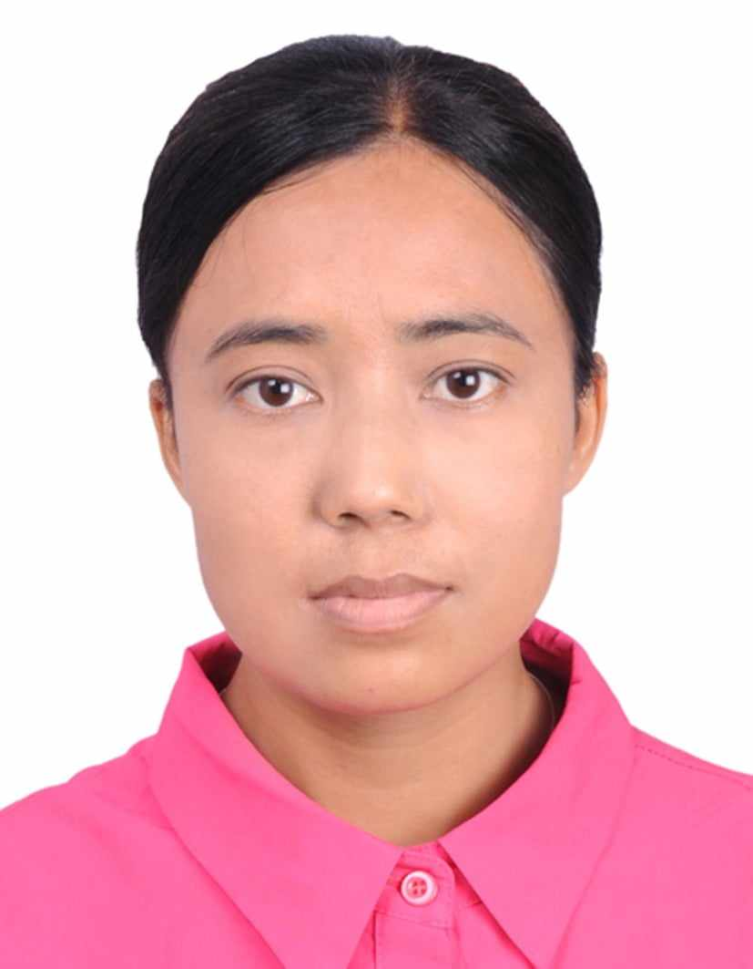
Alain, United Arab Emirates
Contact No : 0542742717
Email Id : prakashbudhamagar25@gmail.com
CAREER OBJECTIVE :
Looking for a position that fits with my qualifications in a large and dynamic organization where I can fully utilize my skills, knowledge and develop new ones to further enhance my career as well as contribute to the growth and success of the company.
PERSONAL DETAILS:
Name : manju lama
Birth Day : 1987/2/11
Nationality : Nepal
Sex : female
Marital Status : married
Languages : English, Nepali
Passport No : 10330635
Date of Issue : 3-april-2017
Date of Expiry : 2-april-2027
Visa Status : visit
ACADEMIC QUALIFICATION:
Secondary School
- Secondary school

- E

- WORK EXPERIENCE:
- Worked as a sales girl 1year at cosmetics shop, Kathmandu, Nepal.
- Worked as a receptionist 3 years at dental clinic, kathmandu, Nepal.

- TRAINING:
- Waiter training complete Kathmandu, Nepal.

- DUTY AND RESPONSIBILITY:
- Taking care of products.
- Merchandising all products and stock management.
- Using every opportunity for self growth with the growth of the company.
- Ability to resume responsibility.
- Punctual, honest, hard worker and good learner.
- Able to communicate clear, objective and professional manner.
- Good customer skill,friendly, polite and approachable.

- giv
- I here by declare that the above mentioned information is true to the best of my knowledge.

