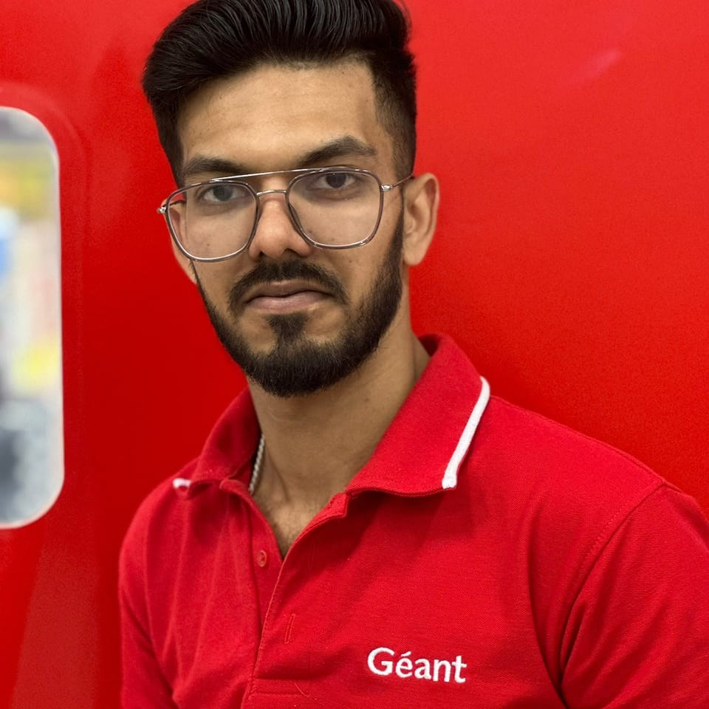
ABDULSHIHAS KARIM
SECTION SUPERVISOR | SHARJAH, United Arab Emirates | +971544502434

Details  Sharjah, United Arab Emirates  +971544502434  Abdulshihas17@gmail.com  Links  LinkedIn  Skills  Customer Service  Ability to Multitask  Fast Learner  Visual Merchandising  Stock counting  Leadership Skills  Ability to Work in a Team  Computer Skills  Microsoft Office  Microsoft Navation  SAP GUI  Languages  English  Urdu  Hindi | Profile  Dedicated supervisor with experience in achieving tangible results and cross-team collaboration. Proactive and excited to partner with like-minded individuals to achieve goals.  Employment History  - SUPERVISOR (DEC 2023 - Present GEANT HYPERMARKET.)  Ordering. Quality checking. Schedule marking for staffs, Inventory controlling, maintaining customer relationship, Ensuring customer focus. Study sales levels of products. Set up pricing strategies. Order supplies. Manage budgets. Monitor compliance with EU marketing standards for vegetables. Use different communication channels. Oversee promotional sales prices. Ensure correct goods labelling.Negotiate sales contracts. Measure customer feedback. Advise customers on preparation of fruits and vegetables. Apply procurement. Maximize sales revenues. Adhere to organizational guidelines. Set sales goals. Apply health and safety standards. Supervise merchandise displays. Manage theft prevention. Handle sensitive products  STOCKER (2017-2021 CAREEFOUR MAJID AL FUTTAIM)  Checking good quality and quantity, allow to deliver the chilled products based on the temperature which is UAE health authority adulated, Handle the expiry and short quantity related all issues, Wastage control, Ensure the FIFO on display and warehouse  Education  GOVERNMENT POLYTECHNIC COLLAGE  [2014 [To] 2017]  [Diploma in Mobility]  Courses  • Attended the training for food handlers 2022 January  • Mobile phone technology April 2014  • Sales Associate January 2016

