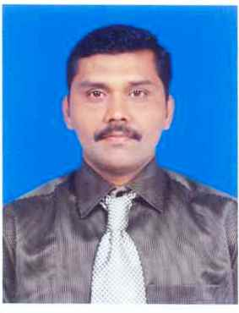
CURRICULUM VITAE

ABDULLAH

+91-9597455314 watsup
+968-78001532
Email id : bdllhafshan@gmail.com

SIR,

I am a Diploma in computer Application and I have more than 10 years working Experience in FMCG organizations for 6 years in gulf country(KSA) in Data Entry Operator cum sales coordinator, 4years as a store keeper (Abudhabi). I am looking for an opportunity to improve my carrier and widen my knowledge I assure the organization that if I Got a chance in this nice organizations. I will exceed management expectation .etc

Technical Qualification:

* I have good knowledge in Data Preparations like Sales Report , Stocks report, Monthly and Daily reports

* I am having good knowledge of prepare Balance sheet, Annual reports etc

Storekeeper(Sharkat Fanniya Omaniya)Shanfari Group of companies
Duration: Oct 2016 Up to date
Storekeeper (Wasita Catering Group LLC-UAE)
(Duration: Apr 2013 up to May 2016)
Main Responsibilities
Maintained store facilities to ensure smooth functioning  Made arrangements and placed orders for new stock and supplies whenever necessary.
- Responsible for upkeep of various appropriate records of materials received.
- Received deliveries of new equipment and ensured that all the supplies were in proper order Stored the supplies and items received in their designated place to avoid time wasted searching for items and general confusion.
- Issued supplies as per the demand of the clients and maintained records of payments.
- Maintained the budget of all the expenditures incurred and presented same to store manager
- Reported to store manager on a regular basis regarding the need/demand of items so future orders could be placed accordingly.

- Monitored the functioning of store equipment and reported problems and failures to the supervisor.

Sales Coordinator (KHALIFAH ABDUL RAHMAN AL GOSAIBI HOLDING CO-KSA)
(Duration: Mar 2007 up to Feb 2010)

- Reporting to Area Sales Manager & Regional Sales Manager

- Coordinate with Sales Team

- Responsible to Submit the report to Head office
- Handled the tasks of dealing with customer queries
- Responsible for taking appointments for different customers
- Handled the tasks of preparing quotations for different products
- Responsible for maintaining files of sales invoice, Performa invoice and purchase orders
- Handled the tasks of promoting products and services of the organization
- Coordinating with accounts for generating Invoice against each purchase order.
Data Entry Operator (KHALIFAH ABDUL RAHMAN AL GOSAIBI HOLDING CO-KSA)

(Duration: Jan 2004 to Feb 2007 )

- Carried out data entry for two large online encyclopedias

- Carried out data entry into customer database for the purpose of Recording one a
Clients invoices

- Was put incharge of training new recruits in working with software used for data entry
- Entered numeric data into excel based program
- Information then sorted, compiled and verified for accuracy
- Compared data entered with source documents and re-entered data into verification format to detect errors
Personal Details

Name : Abdullah.R

DOB : Sep 26, 1974

In Passport. : Sep 26, 1970

Marital Status : Married
Education : Higher Secondary and Diploma in Computer Application

Languages Known : English, Arabic, Hindi, Tamil & Malayalam

Address : O. No. 48 B/1, N.No. 14 Single Tower Mosque Street
Tennur, Trichy-17
Tamilnadu, India

Computer Skills : Able to adeptly use all applications in Microsoft Office

