Muhammad Ahsan Amin
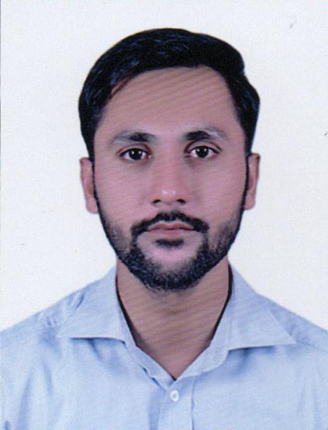

aminahsan351@gmail.com

Ahsanamin124@gmail.com

0306-0541701/03090541701

Results-focused, business development leader specializing in computer fields. I have more than 6 years experience in Dawa Khana Hakim Ajmal, Combine Fabric, DHA, and Honda Ring Road, and Matchless Printing Services, able to effectively coordinate tasks to accomplish projects with timeliness and creativity. Strong meeting planning and facilitation skills; able to communicate effectively with all organizational levels, build relationships of trust. And enlist the participation of team members. Seeking a company where I can use my experience and education to help the company meet and surpass its goals.

Key Areas of Expertise

- Ms Excel , Word  - Internet & E-Mail  - Data Recovery | - Client / Business Relations  - Product/Services Marketing  - In page |  |  | - Client / Business Relations  - Product/Services Marketing

Professional Experience
Having 2 Years of experience as Computer Operator, Sale coordinator at DAWAKHANA HAKIM AJMAL KHAN (PVT) LTD. From 2016 To 2018.
1. Prepare Sale Invoices and make sure correctly entered customer ledger.
2. Prepare Purchase Order and make sure verified from customer
3. Maintain Customer’s Ledger and coordinate with customer weekly.
4. Dispatch Invoices.
5. Prepared Sale Report Weekly/Monthly Basis For CEO.

Professional Experience
Having 1 Year of experience as Management Trainee Officer at Combine Fabric (PVT) LTD.
From 2018 To 2019.
1. Prepare Purchase Order timely and send to concern department
2. Received Purchase Order Sort and Prepared for Production
3. Co-ordinate with Concern Department
4. Prepared Sale Report Weekly/Monthly Basis For CEO.
5. Other Worked Assigned by HOD.

Professional Experience
Having 2 Years of experience as Asst Accountant at DHA Club Lemniscates (PVT) LTD.
From 2020 To 2022
1. Prepared Invoices in ERP (Oracle).
2. Maintain Sale Report Daily basis
3. Received Cheque from members and deposit into Bank
4. Other Works assigned by secretary
5. Other Worked Assigned by HOD.

Professional Experience
Current Working as Computer Operator at Novatex Private Limited Company.
1. Prepared delivery Chillan.
2. Dispatch order timely
3. Prepared invoices against delivery Chillan
4. Invoices send to customers timely
5. Collect cheques from customers and deposit into banks
6. Prepared vendor payable
7. Prepared vendor aging
8. Prepared vendor receivable
9. Prepared vendor aging
10. Prepared stock report
11. Maintain on weekly/monthly basis
12. Prepared employee’s salary, overtime
13. Collect data for income tax and sale tax
14. Prepared PESSI
15. Filling all documents
16. Other worked assigned by HOD

education

- B.com  - Intermediate  - Metric | Punjab University  BISE Lahore  BISE Lahore | 2013  2010  2008 |  | - Client / Business Relations  - Product/Services Marketing

Hobbies

- Cricket  - Reading |  |  |  | - Client / Business Relations  - Product/Services Marketing

