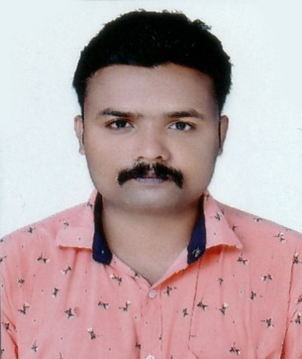 |  | OBJECTIVE  TO PURSE MY CAREER IN A COMPANY THAT MAKES FULL UTILIZATION OF MY INITATIVE,TO WORK AS PART OF TEAM TO ASSUME RESPONSIBILITIES AND IMPLEMENT IDEA AND GROTH OF THE ORGANIZATION AND WORK TO THE VERY BEST OF MY ABILITIES AND BE AN ASSET TO THE ORGANIZATION
personal details  NAME : AMBU.J.S  ADDRESS : AMBUJAM  KOTTIYODU ATTINGAL  KERALA,TRIVANDREM  DATE OF BIRTH : 4/10/1994  GENDER : MALE  MARITAL STATUS : MARRIED  VISA STATUS : VISIT VISA  Mobile no : 0505837949  E Id:Jsambu94@gmail.com  EDUCATION  10TH BOYS SCHOOL ATTINGAL  12 TH HSS – VENJARAMOOD |  | EXPERIENCE  4 YEAR EXPERINCE AS A DELIVERY IN FLIPKART  SHOWROOM, KERALA,INDIA  2 YEAR OF EXPERINCE AS A DRIVER CUM SAILS MAN IN  MOBILE COMPANY, KERALA,INDIA  1 YEAR EXPERIENCE AS A MOBILE TECHNICIAN IN MY G  SHOROOM, KERALA, INDIA.  2 YEAR OF EXPERINCE AS A HEAVY DUTY VEHICLES DRIVING  IN INDIA  PERSONAL SKILLS  COMMUNICATION SKILS, HARDWORKER, PUNCTUAL,  TEAM FACILIATOR, TIME MANAGEMENT, COMPUTER  KNOWLEDGE  LANGUAGES  ENGLISH, HINDI, MALAYALAM, TAMIL.  INTERESTS  . READING .DRAWING .PHOTOGRAPHY .TRAVELING .SPORTS  DECLARATION  . I HEREBY DECLARE THAT ABOVE WRITTEN PARTICULARS  ARE TRUE TO THE BEST OF MY KNOWLEDGE AND BLIEF.  AMBU J S

