RESUME
Personal Details
Name | Arshee Alavi | 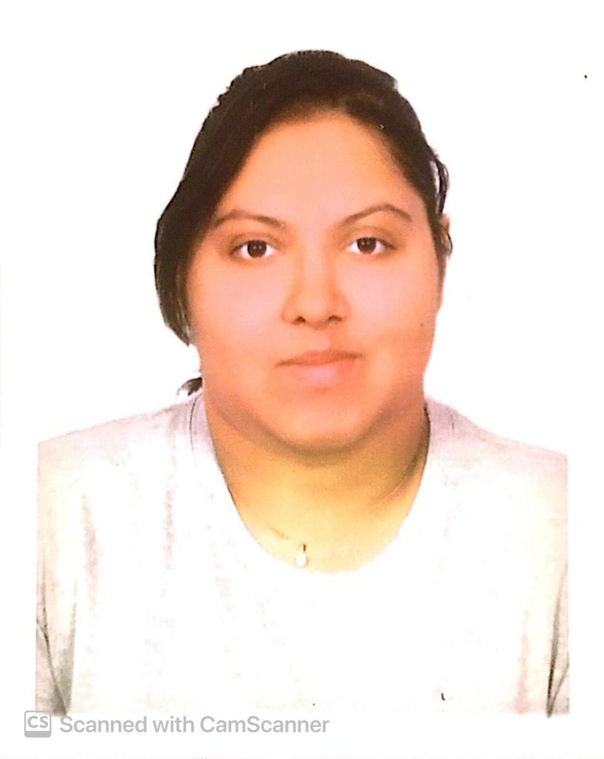
Age | 25
DOB | 8/4/1996
Nationality | Indian
Address | 1701 Beverly Hills,  Opposite shastrinagar, Lane 2 and heritage west Mumbai 400053
Email Id | Arshialavi1701@gmail.com
Mobile number | 8291636854
Martial status | Single

Education skill
S.r no | Degree | Year | Board | Percentage
1 | 10th | 2012-2013 | SSC | 57%
2 | 12th | 2015-2016 | HSC | 46%
3 | Computer course | 2017 | Comsap computer
4 | IETA | 2018-2019 | Explore the world travel academy | ‘A’ grade
Objective:
Work experience

Information technology skills
•Operating system: Windows Xp, Windows vista, Windows 7
•Programming language: C++
•Office Tools .Ms Office
Personal skills
•Positive Attitude, Involvement in work.
•Ability to take responsibility for my actions.
•Ability to quickly adapt to new environment and learn new things.
•Able to multi-task prioritize effectively.
Leisure Activities: Listening to music and travelling.
DECLARATION
I hereby declare that the above mentioned information is true to best of my knowledge

