**Education**

* Short Accounting Course
* Intermediate in Computer Science( ICS ), 2015-17 Punjab College Sialkot
* Matriculation in Computer Science, 2013-15 Alama Iqbal School

**Professional experience and responsibilities:**

* **Administration and Collections representative at Sindbad**

August 2017 – 2023

* Managed daily sales and billing information for the company.
* Dealing with clients and handling payments.
* Tele daily sales cash and collecting money daily for weekly and monthly deposits.
* Making reports of daily sales and cash received .Fax the reports to CEO.
* Kept an accurate record of all collections activities
* Review and expedite accounts, making decisions relating to negotiations and sales.
* Performs related follow-up such as administrative paperwork. Audit of sales and total balance.

Supervise sales team and products.

Stock handling (Cash and files)

Efficiently handled team of 60+ staff.

* **Procurement Officer**
* Negotiate contracts and pricing with vendors
* Analyze market trends and recommend appropriate strategies
* Maintain accurate records of purchase orders, invoices and other documents
* Develop and manage procurement budget
* Collaborate with other departments to identify purchasing needs
* Ensure timely delivery of products and services
* Monitor supplier performance and relationships

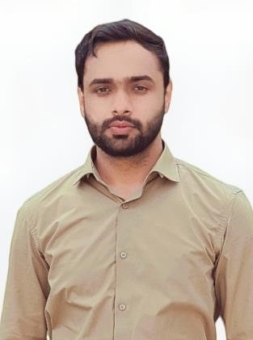

English

Urdu

# **Languages:**

Father name: Liaquat Ali Ch

Date of Birth: 24 Feb -1999

Passport: GL8965251

Nationality: Pakistani

Address: Abu Shagara, Sharjah

Email: axadch707@gmail.com

Phone: +971-564314878

Whatsapp: +923-070716605

Visa Status: 2 year work permit

Microsoft Office

Ability to Work under pressure

Teamwork

Decision Making

Problem Solving

Leadership

Microsoft word

Multitasking

Customer Services

Technical Understanding

Time Management

# **Personal information:**

**Skills :**

Asad Liaquat

## Personal Statement:

Articulate, results-oriented customer service professional. High- performance, demonstrates exceptional creativity, leadership, visionary and humanitarian focus. Committed to achieving outstanding results. Excellent interpersonal and leadership skills. Confident to work autonomously utilizing strong work ethic. Highly motivated, able to set and achieve multiple goals. Self-directed, team player. Dedicated to achieving customer satisfaction as well as meeting or surpassing company expectations. I'm always energetic & eager to learn new skills.