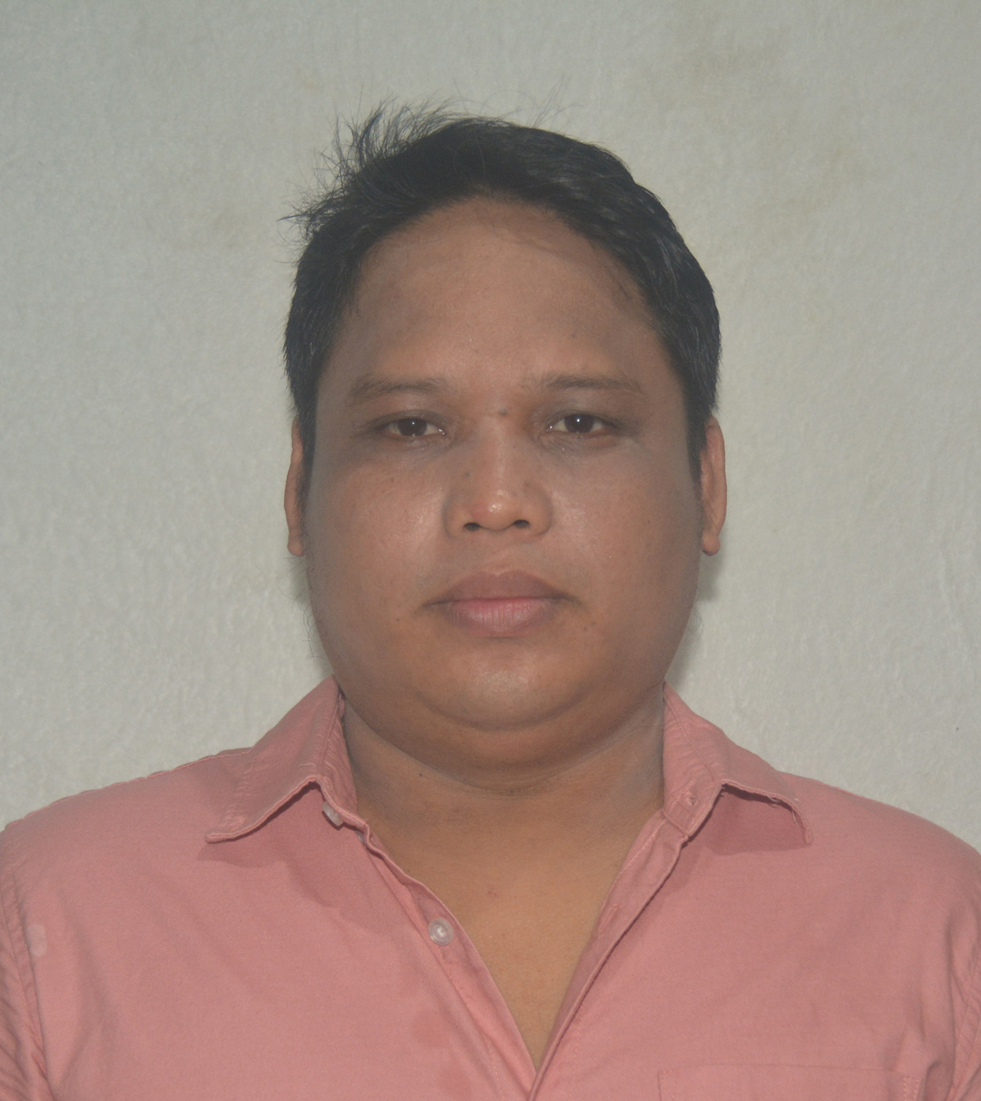
BELLIE FRANCIS M. OBALES
Contact Nos.: (+63) 9452274581
Email Address: belfranz_03@yahoo.com

Career Objective:
To find a challenging position to meet my competencies, capabilities, business minded, skills, education and experience as a electronics engineer.
Personal Data:

Date of Birth : December 3, 1987 Civil Status : Married
Place of Birth : Palompon, Leyte Nationality: Filipino
Height: 165 cm. Religion : Roman Catholic
Weight: 85 kg. Language : English, Arabic, Tagalog & Cebuano
Education:

2005- 2010 University of San Jose-Recoletos Cebu City

Bachelor of Science in Electronics Engineering ( Graduate )

2001 - 2005 Colegio de San Francisco Javier Palompon, Leyte

Secondary
Work Experience:

- Experience Level : I Have been working since 2010

- Business Dry Goods Supervisor – January 2018 to Present
Beljan Merchandize (Isabel, Leyte, Philippines)

- Assess and identify new opportunities for growth in current and prospective markets
- Establish the company’s goals and objectives
- Recruit and train new employees
- Perform regular employee evaluations to determine areas of improvement
- Design business strategies and plans to meet the company goals
- Develop a comprehensive company budget and perform periodic budget analyses

- IT Support – May 2013 to July 2017
Saudi Marketing Company (SAMCO) (Kingdom of Saudi Arabia)

- Install and configure computer hardware operating systems and applications
- Monitor and maintain computer systems and network
- Installation, Network, Repair and Point of Sales (POS), Weigh Scale, Printer, Scanner.
- Oracle User
- Assign with different branches
- talk staff or clients through a series of actions, either face-to-face or over the phone
- work continuously on a task until completion

- Machine Operator – April 2012 to September 2012
Liwayway Marketing Corporation | Central Visayas, Philippines
- Operator in Volumetric and weigher machine
- Maintain and monitor machine to make sure it functions properly
- Understanding of how operated machine works
- Adjust machine as needed for changeovers, different functions, or other varying needs of production

- Computer Technician – June 2010 to March 2012
P&P PC TOOLS | Central Visayas, Philippines

- Computer Troubleshooting, Networking and Repair
- Type of services are computer rentals and computer sales
- Dealing with customers
- Using Adobe Photoshop and Corel Draw for designing and Photo Editing
- Set up hardware
- Install software
- Perform regular upgrades
- Perform troubleshoot activities
- Install well-functioning LAN/WAN and other networks
- Manage network components (servers, IPs etc.)
- Provide technical support

Qualifications:
- Responsible for setting up and maintaining computers/machines and equipments
- Proficient In MS Office Application, Corel Draw & Adobe Photoshop, Oracle
- Providing feedback to foreign and local customers
- Work-Oriented And Strongly Motivated In Accomplishing Assigned Tasks
- Good In Oral And Written English Communication Skills
- Can Work Well Under Stressful Conditions
- Honest and Responsible
- Willing to Work Extended Hours
References:

Mr. Arnie M. Narvasa
Aluminum Fabricator Installer
Bellvue Avenue, Papanui, Christchurch, NZ.
Mobile # +642902007082

Engr. Reynaldo D. Ruedas
OIC, Engineering Computer Laboratories
University of San Jose-Recoletos
Telephone number: 253-7900
Ms. Jiji Rojas
Sales Lady
Prince Super Market, Isabel Leyte
Mobile # 09363913584

I hereby certify that the foregoing data and information furnished here with are true and correct to best of my knowledge and belief.

BELLIE FRANCIS M. OBALES
Applicant

