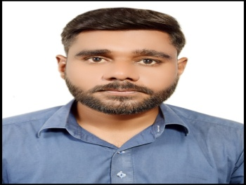

**Muhammad Bilal**

|  |  |  |  |
| --- | --- | --- | --- |
|  | | | |
| |  |  |  | | --- | --- | --- | | **CONTACT** | |  | |  | |  | |  | | (+971) 55-1244067 |  | | muhammadbilalb509358@gmail.com |  | | Dubai, UAE |  | | **EDUCATION** | |  | | Sep-2018  **Bachelor in Science**,  Abbottabad University of Sciences and Technology – *Pakistan.* | |  | | Aug- 2018  **Diploma in Information Technology**- BTE Board Peshawar 2018 | | | **KEY SKILLS** | |  | |  | |  | |  |  * Organizational Skills * Time Management * Interpersonal Skills * Ms office * Installing Windows * Troubleshooting * Removing System Error * Maintaining Record * Friendly & helpful * Adaptable * Well mannered * Articulate * High energy levels * Interpersonal skills * Efficient  |  |  | | --- | --- | | **LANGUAGE SKILLS** |  | |  |   IELTS 6.0 |  |  | |  | | --- | | **PROFILE** | | | Devoted knowledgeable about products and eye-catching display strategies. Organized, hardworking and An experienced with a proven track record of success in meeting and exceeding organizational goals. Possesses excellent communication and problem-solving skills, with the ability to work both independently and collaboratively. | | **PROFESSIONAL EXPERIENCE** | | | Sep- 2023- Nov 2023  ANT Technical Services- **Office Assistant** **, Dubai, UAE**   * Greeting visitors entering the office determined the nature and purpose of visit and directed them to the appropriate destination. * Locating and attaching appropriate files to incoming correspondence requiring replies. * Answering and managing incoming and outgoing calls while recording accurate messages. * Maintaining a clean reception area, including lounge and associated areas. * Maintaining and updating filing, mailing, and database systems, both manually and using a computer. * Performing general office duties, such as ordering supplies, maintaining records management, and performing basic bookkeeping work. * Opening, sorting, and distributing incoming correspondence, including faxes and email. * Operating office machines, such as photocopiers and scanners, and personal computers. | | Sep- 2021- Feb 2023  **Qaabil Solutions Pvt Ltd,Office Assistant Karachi, Pakistan.**   * Greeting visitors entering the office determined the nature and purpose of visit and directed them to the appropriate destination. * Locating and attaching appropriate files to incoming correspondence requiring replies. * Answering and managing incoming and outgoing calls while recording accurate messages. * Maintaining a clean reception area, including lounge and associated areas. * Maintaining and updating filing, mailing, and database systems, both manually and using a computer. * Opening, sorting, and distributing incoming correspondence, including faxes and email. * Operating office machines, such as photocopiers and scanners, and personal computers. | |