BIMAL KUMAR SETHY
 | 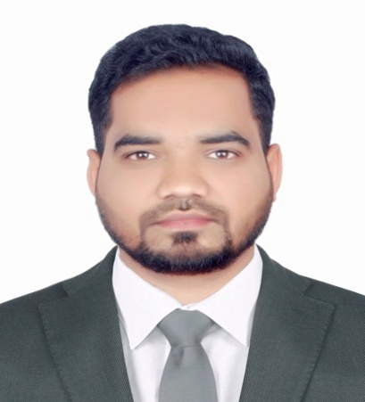  Personal Details  DOB: 15.05.1990.  Nationality: Indian.  Status: Single.  Passport No: U13744058.  Visa: Employment visa.(2 nd VISA)  UAE DL No-798493(BIKE).  (30 Days Notice Period)  Correspondence:  City Center Building, Abushagara, Sharjah.  Flat No.912  Telephone no.  +971 543819624, 559386955.  E-mail:  bimalsethy2021@gmail.com.  Skills  - Customer Services.  - Store display design & setup.  - Time Management.  - Computer Skills.  - Interpersonal Skills.  - Communication.  Hobbies  Travelling, listening music and playing cricket, Helping poor peoples.  Languages Known:  English,  Hindi,  Arabic | Career History  Effective merchandiser with 3+ years of experience. Skilled in store display and design setup. I am seeking employment with a company whereby can grow professionally and personally.  2020 February –Present  Work Experience  CITY CENTER, HYPER MARKET SHARJAH,UAE.  SALES MERCHANDISER (FMCG & DAIRY) WITH CASHIER.  Responsible for performing a wide range of routine branch and customer services duties.  - Maximize customer interest and sales levels by displaying products appropriately.  - Plan and develop merchandising strategies that balance customers expectations and company’s objectives.  - Analyse sales figures, customers reactions and market trends to anticipate product needs and plan product ranges/stock.  - Collaborate with buyes, suppliers, distributors and analysts to negotiate prices, quantities and time-scales.  - Produce layout plans for stores and maintain store shelves and inventory.  - Monitor stock movement and consider markdown, promotions, price changes, clear outs etc.  - Build constructive customer relationships and team with channel partners to build pipeline and close deals.  - Ensure that the prices are updated reguendslarly in the system.  2016 May– June 2018  Work Experience   KOTAK MAHINDRA BANK  RELATIONSHIP OFFICER (DM) ---CUTTACK.  Responsible for all the 2000 mapping customers of the branch and increase the portfolio of branch.  - Achieve monthly sales target in the financial year.  - Ensure penetration in the market through focus on new To Bank acquisition as well solicit existing clientele.  - Prospect in targeted segments that require meeting standards in phone calls, and face-to-face visits.  - Present and sell all personal banking products and services to potential customer in an ethical stricter and professional manner.  - Maintain and develop relationships with existing customer & companies to enhance cross-sell opportunities.  - Ensure End-To-End customer TAT is met for all applications submitted with quality adherence as per target guidelines.  - Ensure strict compliance with the Bank’s policy with regards to product, customer KYC,FATCA,AML CTF and third-party channel interactions.  - Record all sales activities in DSR and update CRM for leads and contacts.  - Participate in all team Activities like Morning huddles, Training and coaching, complete mandatory compliance and fraud trainings, Lean &rewards celebrations.  November 2014 – April 2016  Work Experience  AXIS BANK  Assistant Sales Manager(Teller)---CUTTACK.  Answering customer enquiries regarding their account balance, Receive Loan installment payment from customer.  - Properly check the date, amount, name and sign of the customer on the deposit slip and cheque.  - Properly check the self and account pay cheque of the customer.  - Identifying the fake, damage, multilated, altered and counterfeit money.  - Cross-selling the bank’s services to customer processing automatic transfer, checking cheques and making sure they have been written out correctly.  - Explaining financial fees interest rate and services charge to the customer.  - Answering basic customer questions regarding interest rate and the bank services.  - Balancing currency, coins and check in the cash drawer at the end of the every shift.  Work Experience March 2013-October 2014  AXIS BANK  SALES OFFICER—CUTTACK  Answering customer enquires regarding kyc,opening balance, minimum maintain monthly balance,interest,charges etc.  - Responsible to open 15 Saving and 5 Current accounts and also doing LI,GI,MF,SIP,LOAN etc.  - Responsible to given the right information to the customer all the products of the bank..  PROJECT UNDERTAKEN:  ORGANISATION: SBI MUTUAL FUND  Area: Marketing  Project Topic: (Competitive Advantages and Customer Perception of SBI Mutual Fund)  Division: Bhubaneswar.  EXTRA ACHIVMENT:  - I have cleared NCFM in Capital Market (Dealers) module.  - I have cleared IRDA and AMFI NSIM S-5module.  Academic Qualifications.  SL.NO COURSE UNIVERSITY YEAR OF PASSING  1 MFC UTKAL UNIVERSITY 2012  2 GRADUATE B.B AUTONOMUS COLLEGE 2010  3 INTER MEDIATE B.B AUTONOMUS COLLEGE 2007  4 MATRICK ARUHA HIGH SCHOOL 2005  Declaration  I hereby declare that the information regarding me stated above is true to the best of my knowledge and belief.  Place: BIMAL KUMAR SETHY  Date:

