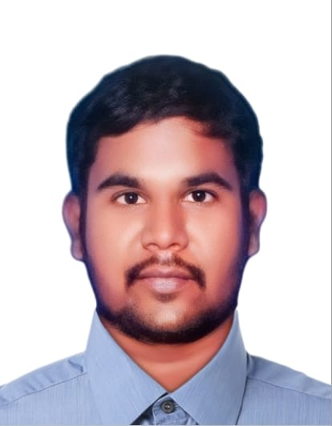 **PROFESSIONAL SUMMARY**

**Honest Cashier capable of managing money, merchandising stock and assisting customers with locating desired items. Successful at cleaning and arranging checkout lanes to maintain professional, visual appeal. Excellent oral and written communication, listening and time management skills with strong attention to detail and superior work ethic.**

|  |  |  |
| --- | --- | --- |
|  | |  | | --- | | **SYED MOHAMED BUHARI** |   CONTACT  Address:Sharjah,United Arab Emirates  Phone :00971558685503  Mail Id :buharismb44@gmail.com |
|  |  |
|  | **SKILS** |

**EXPERIENCE**

**MADHAR SHA AND SONS TEXTILES IN CHENNAI**

**Account Assistant And Cashier Work 2014-2018**

**Sorted and distributed incoming mail to correct recipients throughout busy office environments.**

**Invoices and payments using accounting software**

|  |  |
| --- | --- |
| **Skils** |  |
| * **QuickBooks expert** * **Billing and coding** * **Microsoft Office** * **Expense tracking** * **Managing purchasing activities** * **Excel spreadsheets** * **Letter writing** * **Bookkeeping** * **Accounts receivable and payable** * **Data entry** * **Tally Erp** * **Daily transaction summarising** * **Cash drawer management** * **Cash counting** * **Order taking** * **Cheque cashing** * **Restocking inventory** * **Customer greeting** * **Currency sorting** * **Price changes** * **Scanner operations** * **Credit card payment processing** * **Credit and debit processing** |

**Maintained office files for reliable reference, including electronic and hard copies.**

**Greeted guests and clients with warmth and professionalism.**

**Oversaw daily office operations and equipment maintenance.**

**Managed purchase ledger by finalising statements reconciliations, performing monthly payment runs and registering and coding invoices.**

**Raised sales invoices and reviewed debtor balances to achieve**

**Completed opening and closing procedures each day.**

**Delivered outstanding customer care with proactive sales and listening skills.**

**Reduced customer wait times through optimised checkout processes.**

**Handled cash and card payments with precision, maintaining customer confidentiality and discretion throughout.**

**Used cash registers and POS systems to request and record customer orders and compute transactions.**

**Answered questions about store policies and concerns politely and professionally, supporting positive customer experiences.**

**Checked notes carefully to spot counterfeit currency.**

**Issued trading stamps and redeemed food stamps and coupons.**

**Helped meet business needs by working extra shifts.**

**Assisted with cashier close-down by counting drawer change and processing vouchers.**

**AMPLE MART HYBER MARKET IN BANGALORE**

**Account Assistant And Billing Cashier Work at 2018-2020**

**Received and screened high-volume internal and external communications, calls and email.**

**Responded promptly to telephone enquiries from clients, vendors and customers.**

**Completed banking transactions and carried out basic bookkeeping.**

**Arranged meetings by reserving rooms and making arrangements for snacks.**

**Typed and proofread documents for senior management.**

**Entered handwritten data into computers for easy retrieval.**

**Assisted credit teams with re-invoicing and raising credit notes.**

**Tracked cancelled and reissued invoices for audit purposes.**

**Generated and sent invoices to clients for payment.**

**Formatted billing files to capture client preferences and payment information.**

**Set up new promotions and monitored price changes.**

**Resolved customer complaints and answered queries about store products.**

**Greeted customers entering store and responded promptly to customer needs.**

**Helped customers make product and service selections among range of options.**

**Recommended products and services to customers based on requirements.**

**Trained and mentored new cashiers and clerks in correct processes.**

**Accepted customer payments for tickets and issued papers for admission to events.**

**Used POS register system to total values and complete cheque, card, or mobile payments.**

**Checked customer ID when selling age-restricted items, following store policy.**

**Handled currency payments, secured funds in register and prepared deposits at end of day.**

**Wrapped and bagged purchases for customers to easily carry items without damage.**

**MINT SUPER BAZAAR -BANGALORE**

**Account Assistant and Cashier Work at Jan ,2021 – Aug 2023**

**Tracked payments and outstanding invoices on , promptly following up on**

**invoices by proactively calling clients.**

**Communicated with vendors and clients to facilitate timely payments**

**and reduce outstanding accounts receivable balances.**

**Processed various accounting documents on such as invoices,**

**sales orders and purchase orders.**

**Managed daily bookkeeping functions with attention to accounts receivable**

**, accounts payable, banking reconciliation and disbursements.**

**Used tax and finance knowledge to provide advice and resolve vendor**

**and employee inquiries.**

**Chased missing transactions to help facilitate timely payments.**

**Maintained petty cash for ad-hoc business expenses.**

**Worked with statistical, financial and auditing information to make accurate**

**decisions about accounting needs.**

**Updated balance sheets with accurate asset and liability information.**

**Collated invoices, transaction records and accounting certificates.**

**EDUCATION:**

**Windows Microsoft Office And Tally ERP 9.01- 2011 in CSC Academy Tamil Nadu**

**12th PASS -2010 in Rahmaniya higher Secondary School-Tamil Nadu ,India**

**SSLC PASS -2007- in Rahmaniya higher Secondary School-Tamil Nadu ,India**

|  |
| --- |
| ADDITIONAL INFORMATION |
| * **Name : Syed Mohamed Buhari** |
| * **Father Name : Syed Ahamed** |
| * **Date Of Birth :01/05/1989** |
| * **Sex : Male** |
| * **Religion : Muslim** * **Nationality : Indian** * **Marrital Status : Married** * **Language :Tamil, English,Hindi,Malayalam,Kannada** * **Passport Number :N5395743** * **Place Of Issu : Madurai** * **Date of Expiry :02/12/2025** |

**DECLARATION**

**Writing effective resumes requires including elements that give potential employers a comprehensive idea of your qualifications and professional skills. Among these elements are declarations, which assure prospective employers that the information provided in the resume is true and accurate.**

**Yours Truly**

**Syed Mohamed Buhari**