MR. CHANDRA BUDHA
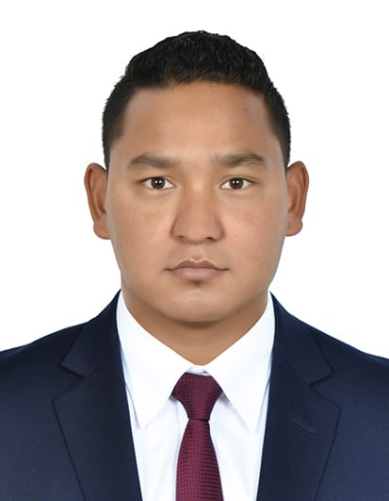  Mobile: +971-527351994  Email Address:  chandrabudha881@gmail.com  Visa Status :Resident  Passport Number:  06068427 / PA0631299  Address:  Burdubai, Dubai,  UAE  Personal Information:  Date of Birth:  May 03,1993  Nationality: Nepali  Language: English, Hindi,  Nepali  Height: 5’7”  License #: 63653475  Education  Completed Intermediate  Noble Academy Higher  Secondary School, New  Baneshwar, Nepal  .  I hereby to certify that above information is true and credible, for further clarification I am very much whelm to be call upon assessment. |  | CAREER OBJECTIVE:
 |  | To succeed in an environment of growth and excellence and earn a job which provides me job satisfaction and self-development and help me achieve personal as well as organizational goals.
 |  | WORK EXPERIENCES:
Sales Merchandiser
- Mars gulf. 3rd Feb. 2020 to till date present
- Al Maya General Trading Co. 23rd Jan. 2018 to 2020
- Sunrise city supermarket LLC 27thDec.2013 to 16jan 2018

 |  | Duties And Responsibilities:
 |  |  | - Strong relationship with shelf boy and manager supervisor
- Attending customer needs/selling high quality items.
- Fulfill any special requests made by customers.
- Maintaining the cleanliness of shelf and module’s where products are located as well as the area of responsibility.
- Assisting customer for the items they wish to purchase and making sure that they reach the satisfactory standard in assisting of customers.
 |  | SKILLS
- Excellent interpersonal skills, ability to work well with others in both supervisory and support staff roles.
- Hardworking, highly creative and resourceful Attention to detail, accuracy and team player.
- Works independently with little to no supervision
- Fast learner and highly coachable.
- Great team player
- Strong intercultural marketing and selling skills
- Ability to be flexible and adaptable to the requirements of the position
- Ability to work under pressure.

