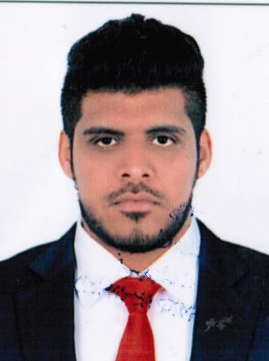

**MUHAMMAD ATIF ANWAR**

**Mobile No: +971505020603**

**Email – Muhammadatif788@gmail.com**

**Dubai, UAE.**

**Objective:-**

To work in responsible position where my educational qualification will go with organization growth the strength with to contribute my service for the achievement of organization goal and for the betterment of my career prospect.

**Work Experience:-**

* Worked with Eurofins Biomnis Middle East as a Sales Representative.
* Worked with Titan gaming technology as Transportation supervisor.
* Worked with International beverages and Filling industry Company as Merchandiser.
* Worked with Dnata as Cargo Service Agent from 2017 to 2020.
* Worked with logistics company PARZEL EXPRESS AND LOGISTICS as a Customer Service Representative from 2016 to 2017.
* Worked with Al Hamd Electromechanical Works L.L.C Dubai as a Admin Assistance from 2014 to 2016.
* Worked as a Air Side Operation/Ground Staff at Dubai Intl. Airport, Terminal 1 and 3 from Sep 2010 to 22th Oct 2014 .
* Worked as a Marketing Sales at Carrefour and Other Supermarkets Dubai for 3 months.
* Worked as a Salesman at Al Muheet Al Atlasi CO. in Dubai UAE for 9 months.
* Worked as a Management Trainee at Bridgeway Electromechanical L.L.C Dubai UAE from 11th Jan 2007 to 30th June 2008.

**Communication Skills:-**

* Good command over English(fluent), Arabic, Urdu, Hindi & Punjabi (Read, Write and speak) .
* Ability to Adopt to a multi-cultural environment.

**Educational Qualification:-**

* High School 12th grade Certificate.
* Computer hardware and Networking Certificate.
* Dnata Safety Management system course.
* Dangers goods aviation safety course.

**Computer Skills:-**

* Certificate in Computer Hardware and Networking from Oasis Educational Institute, Dubai.
* Basic computer course with internet.
* Proficient in computer application.
* Typing speed 40
* Good Knowledge of MS Word, Excel, PowerPoint, Access, sending and receiving Emails, internet surfing.

**Valid UAE Driving License Details:-**

* Type : Light Vehicle.
* Issue Date : 05/07/2006
* Expiry : 05/07/2025
* License No : 1062441

**Personal Details:-**

* Marital Status. : Married
* Gender : Male
* Date of Birth : 31/01/1988
* Nationality : Pakistani
* Religion : Muslim

**Reference :-**

Will be provided upon request.

**Declaration:-**

I hereby declare that the above mentioned information is true and correct to the best of my knowledge and belief.

***Muhammad Atif Anwar***