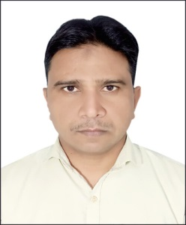**Curriculum Vitae**

**TOUFEEQUE AHMAD KHAN**

**Mobile: 0097156 9565110**

**E-mail: toufeeqe@gmail.com**

**Carrier Objective**

To obtain a position in an established organization that may provide me a chance to utilize my work experience and knowledge with a substantial carrier growth.

**Languages**

English, Arabic, Hindi & Urdu

**Work Experience**

**P R O**

Worked as a PRO AL RIYAH documents clearing in Kingdom of Bahrain from 2008 to 2020

Handling Customer at Reception

Customer phone call and Email replying

Gosi work for worker and Bahraini

Work visa for worker and renewal work visa

Updating salary of employees

Handling and processing immigration work for employees

Passport handling and processing for workers

Monthly bank reconciliation

**Educational Qualification**

10th pass(UP BOARD)

12th pass(Higher Secondary Education from Utter Pradesh State Board)

B.A form VBS PURVANCHAL University jaunpur

M.A from VBS PURVANCHAL University jaunpur

**Computer Knowledge**

Basic Knowledge of computer

A.D.C.A (Advance diploma in computer application)

D.T.P (Desktop publication)

**Skill Profile**

Excellent customer customer services skill

Hardworking team services skill

Have ability to work under pressure

**Personal Data**

Name : Toufeeque Ahmad Khan

Date of Birth : 20/10/1980

Nationality : Indian

Passport No : W0655020

Passport Expiry : 31/07/2031

Visa Status : Visit visa

I hereby certify that the above mentioned statements are correct &true to the best 0f my belief & knowledge.

**TOUFEEQUE AHMAD KHAN**