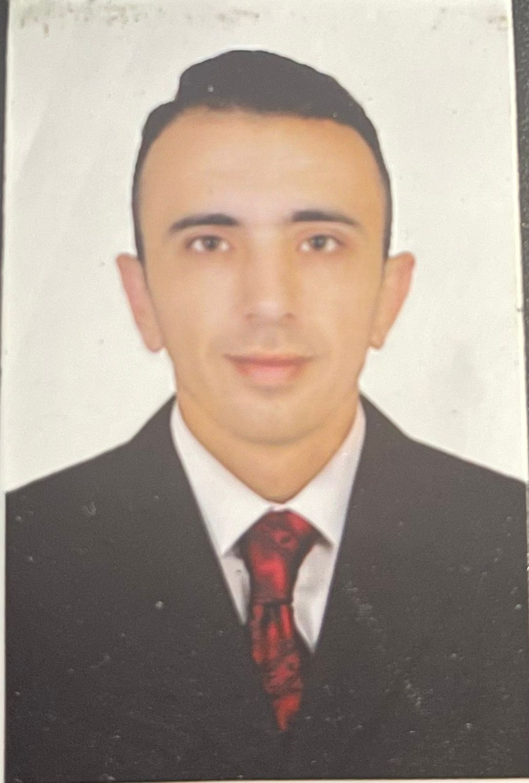

Contact

**Address:**

UAE – Sharjah

**Phone:**

+971508766702 whatsapp

+962790913809 whatsapp (jordanian number)

**Email:**

[**Zaidsardaneh@gmail.com**](mailto:Zaidsardaneh@gmail.com)

[**Zaidsardaneh2708@gmail.com**](mailto:Zaidsardaneh2708@gmail.com)

Languages

Arabic (native)

English

Hebrew

**Zaid .B. Sardaneh**

Summary

Jordanian, 31 years old, Office manager and first-class secretary since 2018. Experience in office work, customer service, secretarial work, administrative organization, and data entry since 2012, salles Experience for 3 years in the online selling , call center for 3 month in UAE.

Skill Highlights

|  |  |
| --- | --- |
| * Data entry * Secretary * Customer service * good knowledge in office software * website designer and developer * teamwork * salles Experience * call center | * Work under pressure for long periods of time * Creativity and dedication to the profession * The ability to update and develop * Speak three language (Arabic – English – Hebrew) |

Experience

**Office admin and data entry in JORDAN GOVERNMENT** – 2012 to 2015

**Secretary in JORDAN GOVERNMENT – 2015 - 2018**

**Office manager in JORDAN GOVERNMENT** – 2018 to 2020

**Office manager** **in** **JORDAN GOVERNMENT** –**JAF** / QUEEN ALIA INTERNATIONAL AIRPORT ( QAIA) – 2021 to 2023

**Customer service 2024**

Education

High school : **irbid high school** (secondary school)

Diploma in Military education - JAF

Certifications

Auditing and information entry clerk course

PHP course

English course

Hebrew course