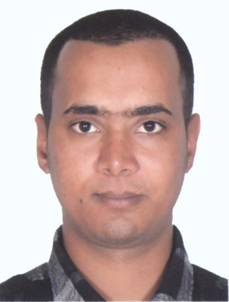

Name : Sujan Adhikari

Address : Rolla street burdubai, Dubai, UAE

Email id : [sujanrinadhikari@gmail.com](mailto:sujanrinadhikari@gmail.com)

Passport no: BA0144008

Phone Number: +971585293201

Objective: Service-oriented professional with diverse experience in front office, hospitality, and customer service roles. Proven track record of delivering exceptional service and building positive relationships with clients and guests. Seeking to leverage skills and experience to excel in a dynamic customer-facing role.

Professional Experience:

Front Office Receptionist, New Hotel Atithi, Kathmandu , Nepal, April, 2021 - December 2023

* Greeted and assisted guests in a professional and courteous manner, providing information and addressing inquiries.
* Managed incoming calls, emails, and correspondence, directing inquiries to the appropriate departments.
* Handled reservations, check-ins, and check-outs using the hotel management system.
* Coordinated with housekeeping and maintenance staff to ensure guest rooms were prepared to standard.
* Resolved guest complaints and issues promptly and effectively, ensuring guest satisfaction.
* Maintained cleanliness and organization at the front desk area.

Crew Member KFC , Kathmandu , Nepal, April, 2015 - March, 2021

* Provided attentive and personalized service to restaurant patrons, ensuring a positive dining experience.
* Presented menus, took orders, and provided recommendations based on guest preferences.
* Served food and beverages promptly and accurately, adhering to service standards.
* Handled payments, processed transactions, and reconciled cash register at the end of shifts.
* Collaborated with kitchen staff to ensure timely delivery of orders and maintain quality standards.
* Assisted with restaurant setup, including table setting, arrangement, and cleanliness.

Waiter Carluccio's, Landmark Group, Dec 2013 to Jan 2015

* Demonstrated teamwork and flexibility in various roles within the company, including food preparation, cashiering, and customer service.
* Provided excellent service to customers, ensuring orders were accurate and delivered in a timely manner.
* Maintained cleanliness and sanitation standards in the dining and kitchen areas.
* Operated cash register and handled transactions accurately, following company policies and procedures.
* Assisted with inventory management, including restocking supplies and conducting inventory counts.
* Upheld company standards for food quality, safety, and customer satisfaction.

Education:

• S.L.C. (2003) Excelsior School​, Kathmandu, Nepal

• +2 (2008) Pentagon College, Kathmandu, Nepal

• Bachelor degree (2011) Nepal Academy of tourism & Hotel Management, Kathmandu, Nepal

Skills:

* Customer Service
* Communication
* Teamwork
* Attention to Detail
* Time Management
* Problem-solving
* Multitasking
* Cash Handling

References:

Available upon request.