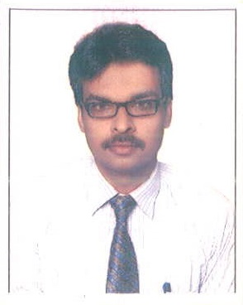 | - G RETHISH PANICKER  CAREER OBJECTIVE  To be associated with a progressive organization that will use my education, skill, abilities and potential, where I can effectively contribute to operations in my capacity that best matched to my skill and experience  Current salary : 1,90,000/ Annum , Expected Salary : 2,00,000/Annum
CONTACT  Neduvakkadu ( H )  Kunnamma, Kavalam.P.O,  Alappuzha – 688 506  Mob : +91 7024690072  +91 9516848300  LANGUAGES KNOW  - English  - Hindi  - Malayalam  PERSONAL DETAILS  Father : Late. K.Gopalakrishna Panicker  Date of Birth : 29-01-1984  Marital Status : Unmarried  Nationality : Indian  District : Alappuzha  State : Kerala  RESPONSIBILITES  - Sales promotion and target  - Customer counts  - Plan events  - Advertisement and marketing events  - Enforce market rules | Education  M.G.M. Senior Secondary School Bhilai  10th ( CBSE ) 2003  NIOS New Delhi  Plus Two ( NIOS New -Delhi ) 2005  B.Com  IGNOU - 2012  Experience  Worked for John Distilleries Pvt. Ltd, Raipur Chhattisgarh as an Office Executive from July 2007 – till Sep 2012  Worked for Crown Distilleries Pvt. Ltd, Raipur Chhattisgarh as an Office Executive from Oct 2012 – April -2014  Worked for ABM Marketing Bhilai Chhattisgarh as a Sales Officer from Aug – 2014 to March 2018  - Worked for Chandra Maurya Cinemas ( Single Screen Theater ) as a Duty officer from 2019 to till 2021  - Working as route sales executive in Anugraha Food Products from 2021 till date  ADDITIONAL QUALIFICATION  - MS-Office, Tally  DECLARATION  I hereby declare that the above information are true, complete and correct to the best of my knowledge and belief. I shall discharge all duties interested to me to the entire satisfaction of all concern.  Date :  Place : G. RETHISH PANICKER

