**VAISAKH M.V**   
E-mail: vaishakmv@gmail.com

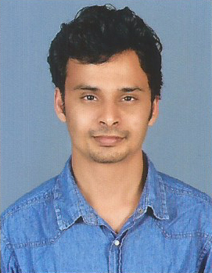

Phone No: 7902602140

**CAREER GOALS:**

Looking for a better position in logistics area to utilize my skills

**WORK EXPERIENCE**

* Working as Regional Logistics Coordinator at AGS Transact Technologies LTD from 2018
* Worked as Marketing & documentation Trainee in Albatross Shipping Ltd (Transworld group) at Tuticorin for the period 3 Months
* Worked as Logistics Coordinator in Middle East Meat Company LLC from 2013 to 2017

**ABILITIES:**

• Posses good leadership and management skills.

• Proficient in Microsoft Word, Excel and the Internet.

• Good communication and interpersonal skills.

• Goal oriented problem solving skills.

• Problem sensitivity and inductive reasoning.

**PERSONAL DETAILS:**

Father’s name : Mr. M. A. VisalakshanSex : Male   
Marital status : Married  
Religion : Hindu  
Nationality : Indian  
Languages Known : English, Malayalam, Hindi & Tamil  
Permanent address : Madathumkadavil House, Parayakad,  
 N Paravur P.O,  
 Ernakulam-683513  
Date of Birth : 25/09/1989

Passport No. : J 0883767

**FUNCTIONAL SKILLS**

• Analytical ability, Communicative ability and Ability to work in a team.

**HOBBIES**

• Listening music, Travelling and Reading Books.

**EDUCATIONAL QUALIFICATIONS**

|  |  |  |  |  |  |
| --- | --- | --- | --- | --- | --- |
| **COURSE** | **DISCIPLINE/**  **SPECIALIZATION** | **SCHOOL/ COLLEGE** | **BOARD/ UNIVERSITY** | **MONTH/**  **YEAR OF PASSING** | **MARKS %** |
| Certificate | Logistics &  Supply Chain Management | School of Logistics Management and Technology, Kochi | CII-Institute of Logistics Chennai | 2012 | 60% |
| PG Diploma in  Logistics & SCM | Logistics &  Supply Chain Management | School of Logistics Management and Technology, Kochi | M.S. University, Thirunelveli | 2012 | 65% |
| B.Sc | Chemistry | UC College, Aluva | M.G. University | 2011 | 60% |
|  |  |  |  |  |  |
| Plus Two | Science | Paliyam Govt HSS, Chendamangalam | Kerala State Board | 2007 | 70% |
| 10th | SSLC | DDSHS, Karimpadam | Kerala State Board | 2005 | 70% |

**EXTRA CURRICULAR ACTIVITIES**

• Attended 10 days Training program on “**Community Development**” for National Service Scheme in Pattimattom, 2009.

• Co-ordinated fund collection drive for Orphanages at UC College, Aluva in 2009.

**REFERENCE:**

Sajive kumar

Regional Manager

Ags Transact Technologies

Mob:+919946599220

**VAISAKH M.V**