Mohammed Dawood AliC E R G E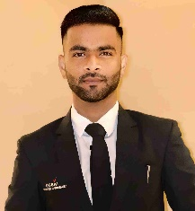 E R

# Executive Summary Career History

As a Concierge i am Capable of gathering information about community amenities and recreational activities.

Superior scheduling and organization skills. I am having excellent communication and interpersonal skills with customer service orientation. Expert multitasked, handling reservations and guest accommodations efficiently.

# Reach me at:

**Cell: +971-581468828**

**E-mail : mrcute67k@gmail.com**

**Address: Al Marabea Street, near new Grand city mall, Al Quoz Dubai, UAE.**

Working As A Loan In charge cum Cashier In Seva Society, Nizamabad From 2020 To Till Date.

2 Years Experience As A System Operator.

## Working as A concierge

### Ejadah Asset management group LLC| 2023 - Up- to- Date Site: Emaar Beach Isle.

Jumeirah Beach Residency [JBR]

# Education History

**Bachelor of Commerce (B. Com) , Pragathi Degree College, [2019-2021], Nizamabad, Telangana.**

Intermediate from Board of Intermediate Education in 2019, Telangana, India.

S.S.C from board of secondary education in 2017.

**TECHNICAL SKILLS**

* **D.C.A [ Diploma In Computer Application]**
* **TALLY ERP9**

# Core Skills

* **Multitasking**
* **Customer service**
* **Expert in Providing Front Desk Customer care services.**
* **Ability to Analyze Data**
* **Critical Thinking Skills**
* **Problem Solving**