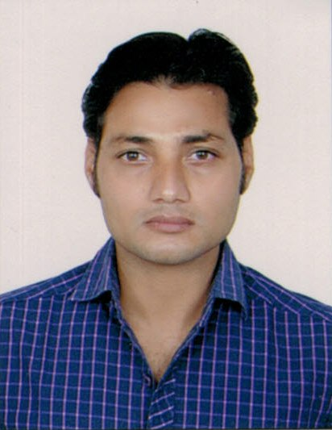**RESUME**

DURGESH KUMAR SHRIVASTAV

Mob.96550455101

[durgesh.shrivastav@gmail.com](mailto:durgesh.shrivastav@gmail.com)

Career Objective:

* To expand my career technical professional with the objective and adding value to the organization by achieving professional excellence through continuous learning and improving me.
* Adopting to new trends in technology, bringing up innovative ideas to solve problems, and contributing to the industrial world is what I seek to achieve - specifically, in the Printing Industry as a Printing Technologist and Consultant in this modern world where each new day sees a series of new concept and innovative application.

Work Summary:

* **Stock inventory management** **and logistic** .

German press company for printing and packaging W.L.L.

Location: Kuwait

**[Jun-2022 to Till**

* **Stock inventory management**.

Mittal International PVT LTD.

Location: Sec-30, Chautala Road, Near Shri Krishna Goshala, Panipat Hariyana

**[Jan-2021 to June- 2022**

* **Production Planner** **& Store Inventory controlar .**

Buck Press Limited

Location: Accra- Nsawam Rd, Opposite Unity Oil, Ofankor | Postal Address:  Box an

12321 Accra - Ghana **[Aug. 2017 to Jan. 2020]**

* **Planning Coordinator.**

Majan printing & packaging .co L.L.C

RAK, Al Jazirah Al Hamra, Po: Box No: 6353 Dubai

**[Oct. 2014 to July.2017]**

* **Planning Coordinator**

P. R. Packaging Limited

Sector 4, Faridabad-121102, Hariyana, India

**[Jan. 2013 to July.2014]**

* **Hyper City Retail India Ltd.**

Team Leader in electronic and check out department.

Royal Minakshi Mall Bangalore India

**[Jan. 2010 to July.2012]**

Job Description:

* Inventory controller and material inward & outward update in ERP system.
* Preparing report as follow to be submitted to the management.
* Daily production report & Performance report Machine wise.
* Daily machine down time reports.
* Daily basis machine Analysis reports.
* Weekly Production reports.
* Operator performance reports.
* Production status reports.
* Quarter wise reports.
* Sheets lost analysis reports.
* Machine utilization reports.
* Entering all details of work order in the system.
* Paper and card materials calculation job wise.
* Machine wise job scheduling according job priority.
* Store stock maintained and stock update.

Job profile:

* Inventory controller Mittal International PVT LTD Panipat Hariyana.
* Production planner & store managing Buck press limited Accra Ghana.
* Production coordinator Majan printing and packaging Dubai.
* Production coordinator PR packaging Haryana
* Handling laptop and mobile software and hardware sale and service. Hyper city India LTD:

Work experience:

* Inventory controller in Mittal international PVT. LTD.
* 3-years Production Planner & store managing buck press limited (Accra Ghana).
* 3-years planning coordinator Majan printing & packaging (Dubai).
* 1.5-years planning coordinator P.R. packaging (Haryana, India)
* 1-year trainer Hi-Techinstitute (New Delhi -India)
* 2-years Mobile Hard ware &software in LG care in (Lucknow U.P.)
* 2-year TEAM LEADER electronic department handling Laptop and Mobile in Hyper City Retail India LTD. (Bangalore - India)

Qualification*:*

* Diploma in computer PGDCA.
* Post-graduation diploma in computer application.
* Diploma in electrical state board of technical education Bihar.
* Diploma in mobile technology from Delhi Hi-Tech institute.
* B.A- SBM PG COLLAGE (KUSHINAGAR, FAZIL NAGAR)
* Intermediate (Second.div) from U.P Board.
* High school (First.div) From U.P Board.

Technical skills:

* MS office very good knowledge in (Excel, word, power point).
* Enterprise Resource Planning system &Systems Applications Products.
* Mobile hardware and software.
* Assembling of Mobile & Computer

Passport Information:

* Passport no.: -R8076251
* Date of issue: - 12/06/2017
* Date of expiry: -06/06/2027

Personal profile:

* Father’s Name : Late-Shailendra Srivastav
* Date of birth : Aug 20 -1989
* Gender : Male
* Marital Status : Married
* Nationality : Indian
* Domicile : Uttar Pradesh
* Linguistic Ability : Hindi, English
* Permanent Address : Village& Post – Fazil Nnagar
* District : KushiNagarUP