

**FARHAN BASHEER**

**Contact Number**

:

+91

8547938397

,9446474558

**Email ID**

:

farhanbasheer06

@gmail.com

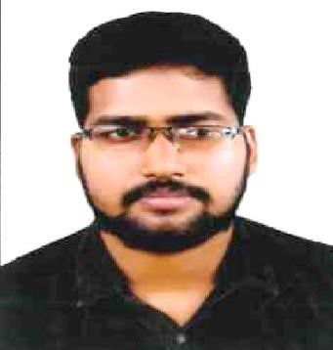

# CAREER OBJECTIVE

To lead and be a part of competitive and growth-oriented team in a lively environment, highly motivated, which offers depth and diversity of exposure, enables me to learn and use my proficiencies for the best benefit of the organization.

**WORK EXPERIENCE**

* **Sales supervisor : 2 YEARS** Metro Wedding Plaza Angamaly
* **Sales man** : 6 months St. Joseph Mobile World , Kakkanad
* **Store In charge** : 1 year Fabindia , Angamaly

# ACADEMIC PROFILE

s

**B.Com Co-Operation**

* St.Anns College Angamaly
* MG University Kottayam

**Intermediate [HSE]**

* De Paul Angamaly
* Kerala Higher Secondary Education Board

**Matriculation [SSLC]**

* GHSS Chengamanad
* Kerala State Education Board **Computer Knowledge**
* Diploma in Tally ERP 9 with GST Expert
* Diploma Indian Foreign Accountant

# KEY SKILLS

* Good communication skills.
* Capable to handle and work under any pressurized environment
* Service Oriented easily adaptable to changing environments
* Willing to learn and stay abreast of latest technologies
* Punctuality

**PERSONAL INTERESTS:**

* Music & Movies
* Travelling
* Reading

# PERSONAL PROFILE

|  |  |  |
| --- | --- | --- |
| • | Languages Known : | English, Malayalam |
| • | Nationality : | Indian |
| • | Date of Birth : | 06-02-1997 |
| • | Gender : | Male |
| • | Father’s Name : | Basheer.E.M. |
|  |  |  |

# Communication Address

Elamana House

Chengamanad.P.O

Aluva-Ernakulam

Kerala-india

Pin-683578

## DECLARATION

I hereby declare that the details furnished above are true and correct to the best of my knowledge and belief.

Date: 06-05-2023

Place: Chengamanad