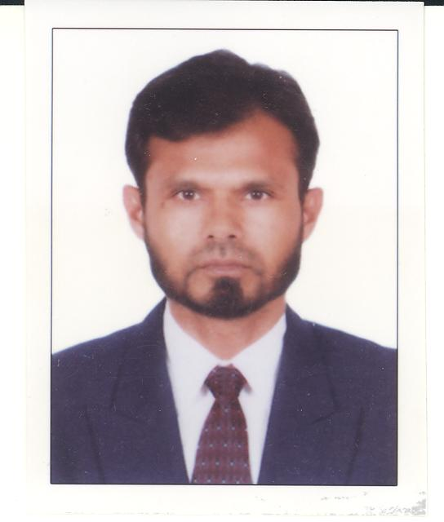
Farid Ahmad.
FUJAIRAH, U.A.E
Mobile..+971509785683
Email : farid2fds@yahoo.com
Tourism Visa 60 Days End 03Jan

Objective | To establish myself at reputed position that will enable me to maximize contribution to the  company and grow.
Professional experience | Presently Working for Asian Building Contracting L.L.C.Fujairah, Electrician Forman from 10TH Jan 2006 to 30 Oct 2013 after work PRO with effect from 30 Oct 2013 to Till Date 25 Jun 2023.  Worked for Al Hasani Electrical Contracting, Fujairah, U.A.E as Electrician also Office Assistance  from 20th Feb 1999 to 06th Sep 2004.  Worked for Holiday Beach Motel, Dibba, Fujairah, U.A.E as Maintenance Technician  (A/C & Electric) 16th Jan 1996 to 13th Feb 1999.
Summary of Education | Bachelor of Arts 1995  Mithla University, Darbhanga, Bihar , India  10+2 I.A 1992  Bihar Intermediate Education Council, Patna India.  Secondary  Bihar Secondary School Board , Patna India 1990
Technical Qualification | Refrigeration & Air Conditioning  Dynamic Technical Institute from Calcutta, India  Basic Computer : MS Office
Personal details | Date Of Birth : 06th Jan 1974.  Nationality : Indian  Visa Status : 17/04/2020  Martial Status : Married  Religion : Islam  Visa Expiry : 20.03.2022  Passport Details :  Passport Number – Z 2662355  Place of Issue – Dubai  Date of Expiry: - 09th July 2024  Extra Hand : UAE Driving license for L.D. Vehicles.  Driving licenses No. 48383  Date of Issue 02/11/1999  Date of Expiry 08/09/2024
Languages | Read: English, Hindi., Urdu , Arabic  Write: English, Hindi, Urdu  Spoken: English, Urdu, Hindi, Arabic
Hobbies | Traveling  Learning Languages  Social Gatherings
Personal Attributes | Extremely hard working  Quick to learn with excellent retention power  Ability to work under pressure

