Education

**Faculty of Commerce – Menoufia University**

**Department :** Accounting

**Graduation year:** 2017

Experiences

* **A clothing store salesman for five years.**
* **Customer service at Telecom Egypt for two years**
* **Accountant at Al Noor Tourism Company for six months**
* **Accountant in a pharmaceutical company for one year**
* **Seller and baker at Hyper Nesso for a year until now**

Skills Highlights

* **Good deiling use computer**
* **have Experience with ( Microsoft Excel )**
* **I am good at dealing with clients**
* **Regular on time**
* **Easy To Learn And To Be Developed .**
* **Ambitious Trust And Sincerity .**
* **High Communication Skills .**
* **Work Under Any Pressure .**
* **Ability to Work In Groups .**
* **Work Hard.**

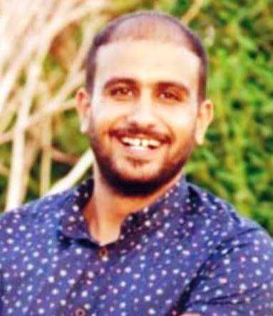

**Mohamed Fawzy AbdElmotelb**

Contact

**Address :**

**Abu Dhabi Al Ain – United Arab Emirates**

**Phone:**

**0502512038**

**E-Mail:**

**mohamed.fawzy15995@gmail.com**

Languages

**Arabic :** Mother Language

**English :** good

Personal information

**Date of Birth :** 15/9/1995

**Age : (27)**

**Nationality :** Egyptian

**Religion :** Muslim

**Martial Status :** Single