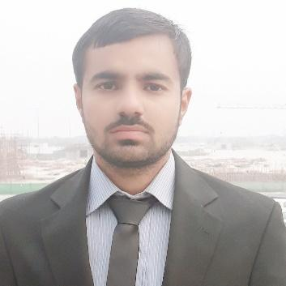  ADDRESS:  AL-FIKREE 2, FLAT NO.  104, BUR DUBAI  (DUBAI)  PASSPORT No:  WF1831321  Cell No. :  +971526702901  E-mail: hammadaslam416@gmail.com  Date of Birth :  13/03/1995  Nationality:  Gujranwala Punjab Pakistan  Visa Status:  Visit Visa  Language:  Urdo(basic)  English  Punjabi(basic) | Hammad Aslam  OBJECTIVE  My principle objective is to work in a well reputable organization among best professionals and in a challenging atmosphere that offers enormous chances of growth and further facilitate my ability to help the organization to reach its strategic goals.  Experience  Sabri’s Interprises  - Accountant , 2019- Dec-2023 Gujranwala Punjab Pakistan  - Computer Operator  ADDITIONAL SKILLS  • Data Entry  • Financial Management  • Payroll Processing  • Regulatory Compliance  • Account Reconciliation Specialist  • Accounting and Bookkeeping  • Account Reconciliation  • Accounts Payable and Receivable (AP/AR)  • MS Office Suite  • Bookkeeping  • Report Generation and Statistics  • Invoice Preparation  • General Ledger Accounting  • Bank Reconciliation Processes  • Account Reconciliation Processes  • Finance Management  SUMMARY OF QUALIFICATIONS  2014-2018 Govt. Post Graduate College Gujranwala affiliated to  Punjab University  BS (Hons) commerce CGPA (2.76) 77.00%  2012-2013 Govt. Community College for Boys Qila Didar Singh  (I.Com) (573/1100)  2011 Govt. High School No.1 Qila Didar Singh  Matric (science) (666/1050) 1st Division  SPECIALIZATION  - Specialization in Finance.  Reference will be furnished on demand.

