**Hamza Saleem Butt**

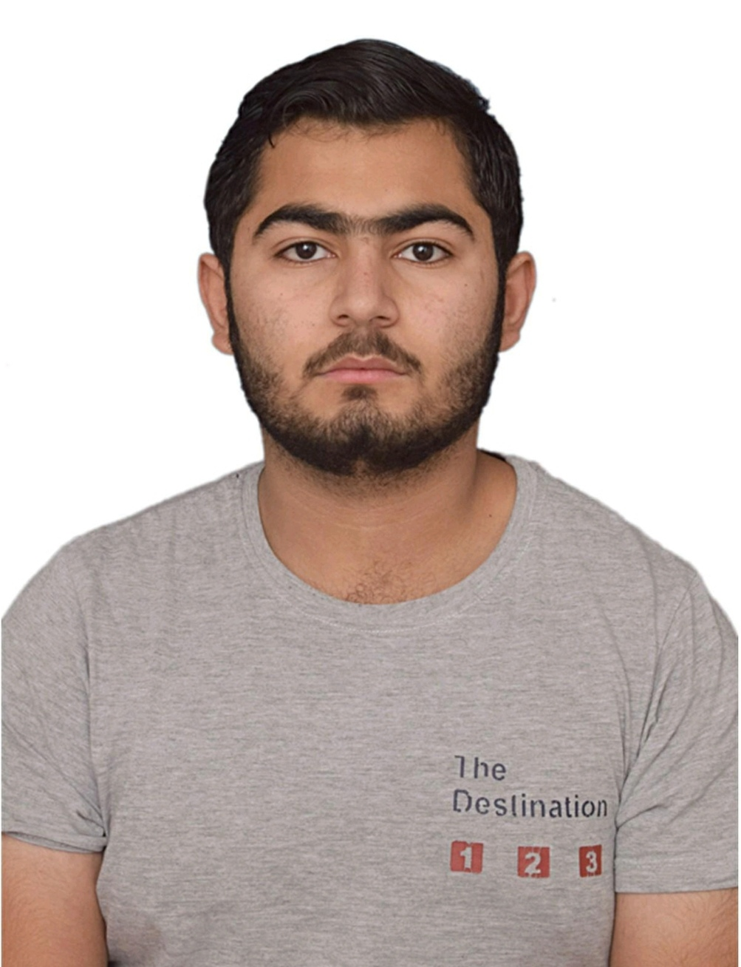

**Email:**[**Hamzabutt81773@gmail.com**](mailto:Hamzabutt81773@gmail.com)

**Ph #+971-581391556**

**Courses:**

* **Typing course**
* **MS word**
* **English proficiency course**
* **Customer service training**
* **Inventory management course**

**Skills:**

* **Customer service**
* **Cash handling**
* **Inventory management**
* **Team leadership**

**Strengths:**

**Customer service**

**Cash handling**

**Inventory management**

**Stress management**

**Able to work in pressure**

**Team work management**

**Other information**:

**Nationality: Pakistani**

**Passport #: AV3494032**

**Experienced cashier & customer service specialist**

**Summary:**

Experienced cashier with excellent customer service skills, adept at managing high-value cash transactions, and efficient inventory management. I have proven track record of elevating customer satisfaction and reducing wastage. Keen to leverage these skills and experience in the grocery store.

**Experience:**

**Senior grocery cashier**

**HS Mart**

Responsible for cash transactions, customer service, inventory management

* Handled average daily cash transactions worth 100,000rs or more
* Assisted customers, improving customer satisfaction by 10%
* Managed grocery inventory

**Cashier**

**Cash & Carry**

Responsible for cash transactions and customer service

* Improved customer service, increasing satisfaction by 15%
* Handled daily cash transactions worth 80,000rs or more

**Qualifications:**

**Intermediate in humanities (2021-2023)**

**Superior college for boys**

**Matriculation in computer science (2019-2021)**

**Govt. Islamia high school no 1**