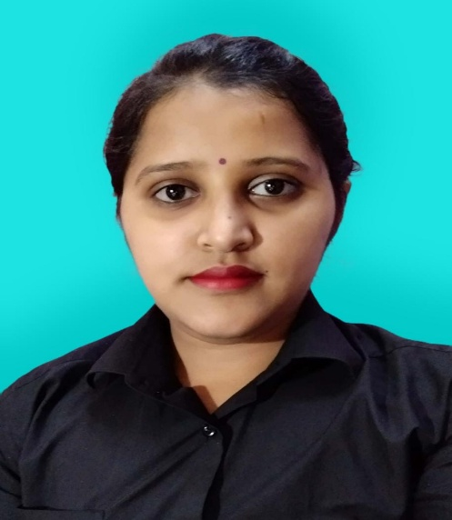

Ramandeep kaur

Address : crystal blue building, Al barsha

Email I’d: [ramandeepkaurkalsi6@gmail.com](mailto:ramandeepkaurkalsi6@gmail.com)

Mobile no : +971553458009

+971553547629

# Objective

To obtain a challenging position in the field for carrier advancement edge where experience, education training and a strong professional growth can be productively utilized .

# Experience

1 year experience in Xshot café and restaurant as a barista and cashier in Alain

2 year experience in grand hyper co. operate company , new seashell restaurant in Barsha Height Dubai

# Education

10th from punjab school education board 2010-11

12th from punjab school education board 2012-13

BA from guru nanak dev university amritsar 2013-16

# Skill

Application: Ms office: Ms word, Ms power point and Ms excel

Learn fast , friendly attitude, hard working.

# Language

English

Punjabi

Hindi

# Personal details

Name. : Ramandeep kaur

Date of birth. : 6.6.1996

Gender. : female

Nationality. : Indian

Passport number: U8099492

Visa status. : Employment visa

# Personal traits

Capable of assuming responsibility. A friendly attitude in general .enjoy hard work . Retain the capacity to work anyone and anywhere