CURRICULUM -VITAE

KHALID ALI 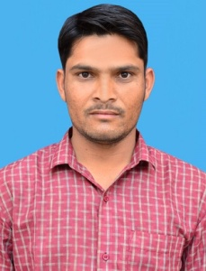

**VPO-Balod bhakhran Th-Fatehpur**

**Sikar(Raj) Pin-332305**

**Mob.- 9660384625**

**Email Id- Khalid.ali34@gmail.com**

# OBJECTIVE

To seek opportunity for professional growth and be part of an organization which uses my knowledge for the development of its process of growth while giving me an opportunity to learn and enrich my knowledge.

**QUALIFICATIONS**

* Secondary Passed From Board of Rajasthan, Ajmer
* Senior Secondary Passed.From Board of Rajasthan, Ajmer
* Complete B.TECH(CS) From Rajasthan Technical University, Kota

**Professional Background**

* Computer Knowledge(MS-EXCEL,OFFICE,POWER POINT)
* Good knowledge of internet
* Data entry

## Hobbies

* Play Games.
* Internet surfing

## STRENGTHS

* Commitment and hard work.
* To Work in any kind of environment.
* Have good communication skill**.**
* Positive attitude

## PERSONAL SKILLS

Comprehensive problem solving abilities, excellent verbal and written communication skills, ability to deal with people diplomatically and willingness to learn.

**PERSONAL INFORMATION**

Father’s Name **:** SHOKAT ALI Date of Birth **:** 04 July 1991

Marital Status **:** Married

Sex **:** Male

Language Known **:** Hindi, English

Nationality **:** Indian

Passport No. : L3158107

**I do here by declare that the information furnished above is true to best of my Knowledge.**

PLACE: **JAIPUR**

DATED:

**(Khalid Ali)**