**MARK JAYSON PACPACO RUIZ** 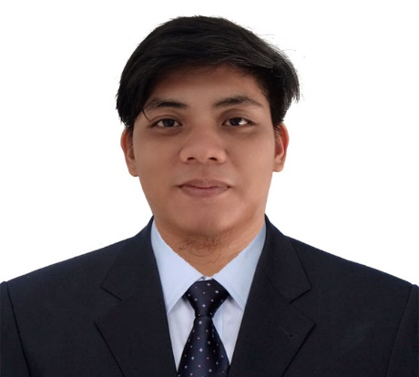

406 Greenland Building Al Badaa, Dubai UAE

[ruizmj930@gmail.com/mjpacpaco1999@yahoo.com](mailto:ruizmj930@gmail.com/mjpacpaco1999@yahoo.com)

971581887558

**OBJECTIVE:**

As a bright and ambitious person, I enjoy working in a fast paced, highly motivating position where I can assist others while challenging and expanding my knowledge and understanding of the task at hand. I am seeking a position that will utilize my skills and offer the challenge for the advancement as well as allow me the opportunity to gain additional skills and experience.

**PERSONAL INFORMATION**

AGE: 24 years old

BIRTHDATE: September 30, 1999

GENDER: Male

CITIZENSHIP: Filipino

RELIGION: Roman Catholic

FATHER’S NAME: Rogelio Ruiz

MOTHER’S NAME: Sonia Ruiz

**SKILLS AND ABILITIES**

* Computer Literate
* Good in communication skills
* Can handle customer concerns
* Hardworking
* Fast Learner
* Responsible
* Willing to be train
* Able to work under pressure without supervision

**EDUCATIONAL BACKGROUND**

**TERTIARY**

**NORTH LUZON PHILIPPINES STATE COLLEGE**

Brgy. San Nicolas Candon City, Ilocos Sur, Philippines

Course: Bachelor of Arts in Political Science

S.Y. 2022

**SECONDARY**

**Senior High School**

**Humanities and Social Sciences Strand**

**STA. LUCIA ACADEMY**

Barangonong, Sta. Lucia, Ilocos Sur

S.Y. 2018

**Junior High School**

**STA. LUCIA ACADEMY**

Barangonong, Sta. Lucia, Ilocos Sur, Philippines

S.Y. 2016

**ELEMENTARY**

**CANDON SOUTH CENTRAL SCHOOL**

San Isidro, Candon City, Ilocos Sur, Philippines

S.Y. 2012

**WORKING EXPERIENCE**

**SERVICE CREW / ASSISSTANT COOK AT JANRO BUFFET AND RESTAURANT**

Sabuanan, Sta. Lucia, Ilocos Sur, Philippines

November 28,2022-February 14,2023

**Inventory Clerk at Farnaz Ceramic Tiles Inc.**

Paras, Candon City , Ilocos Sur , Philippines

January 17,2024- August 15, 2024

**Mark Jayson P. Ruiz**

Applicant