**CURRICULUM VITAE**

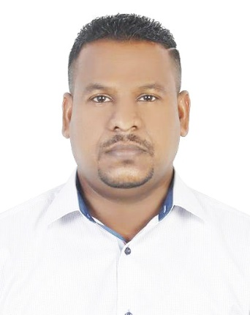

**BUDDHIKA PRABATH JAYAMAHA**

Email:[buddhika.jayamaha@gmail.com](mailto:buddhika.jayamaha@gmail.com)

Contact no: 0582356408

**CAREER OBJECTIVE**

**Company : GREEN PARKING – DUBAI UAE**

Designation : Site Supervisor and Cashier

Duration : 06 Years

**JOB PROFILE**

* Solid interpersonal and customer service skills
* Good attitude able to be courteous with customers under duress
* Manage accurate flow log of parking services
* Handling of cash receipts and payments
* Greeted customers on the front and back end taking and recording payments on the back end
* Maintained outer and inner appearance of structure
* Monthly revenue reports preparing and submit

**Company : LANKA MARKETING RESEARCH BUREAU – SRI LANKA**

Designation : Customer Service & Call Center Agent

Duration : 03 Years

**JOB PROFILE**

* Handling incoming calls and other communications.
* Managing filing system.
* Recording information as needed.
* Greeting clients and visitors as needed.
* Updating paperwork, maintaining documents, and word processing.
* Maintaining supply inventory.
* Maintaining office equipment as needed.
* Aiding with client reception as needed.
* Experience as a virtual assistant.

Company : **ASSOCIATED NEWSPAPER OF CEYLON LTD,** – **SRILANKA**.

Designation : News Web Technician and Office Assistant.

Duration : 10 Years

**JOB PROFILE**

* Collecting News items for Web Cast.
* Creating and Design Web Blogs. (Blogger)
* Content Editing of News Articles.
* Reproducing Images.
* Web Publishing of News Items.
* Data Entry

**Company : FIGS AND OLIVES RESTAURANT CAFÉ. DUBAI U.A.E**

Designation : Waiter, Cashier and Coffee Maker

Duration : 01 Year

**JOB PROFILE**

* Greet guests and accompany them to their tables
* Made various coffee for the customers such as Latte, Cappuccino, Latino, Americano, Espresso Dopio, Mocha etc.
* Present menus and respond to any questions regarding menu items, Serve food and beverages.
* Also served as a cashier, by printing the bills of customers, handing the bills to the customers, collecting their money and giving them their balance.
* Cleaned stations, swept floors and I was responsible for cleaning the coffee machine.

**SKILLS**

* Parking Management
* Trouble Shooting
* Pos Systems
* Validation Solutions
* Cash handling expertise
* Relationship-building
* Data entry
* Written and oral communication skills
* Multitasking Skills
* Inventory control procedures
* Customer- and service-oriented
* Equipment Operation Analysis
* Team work
* Blogger designer
* Supervising

**EDUCATIONAL QUALIFICATION**

* Sri Dharmaloka College, Kelaniya, Srilanka

Passed G.C.E (Ordinary Level) Examination (1999)

**COMPUTER SKILLS:**

* Basic Computer Knowledge.
* Internet and E-mail Operation.
* Web blogger development and design

**PERSONAL PROFILE**

Full Name : **BUDDHIKA PRABATH JAYAMAHA**

Date of Birth : 19/06/1983

Gender : Male

Marital Status : Married

Nationality : Sri Lankan (Sinhalese)

Religion : Buddhist

Language Ability : English (Fluent) Sinhala (Native)

Passport No : N5365630

Visa status : Employment Visa

**DECLARATION**

I hereby declare that the above information is true and correct to the best of my knowledge and nothing has been concealed or distorted.

Place: Dubai.

Date : **BUDDHIKA JAYAMAHA**