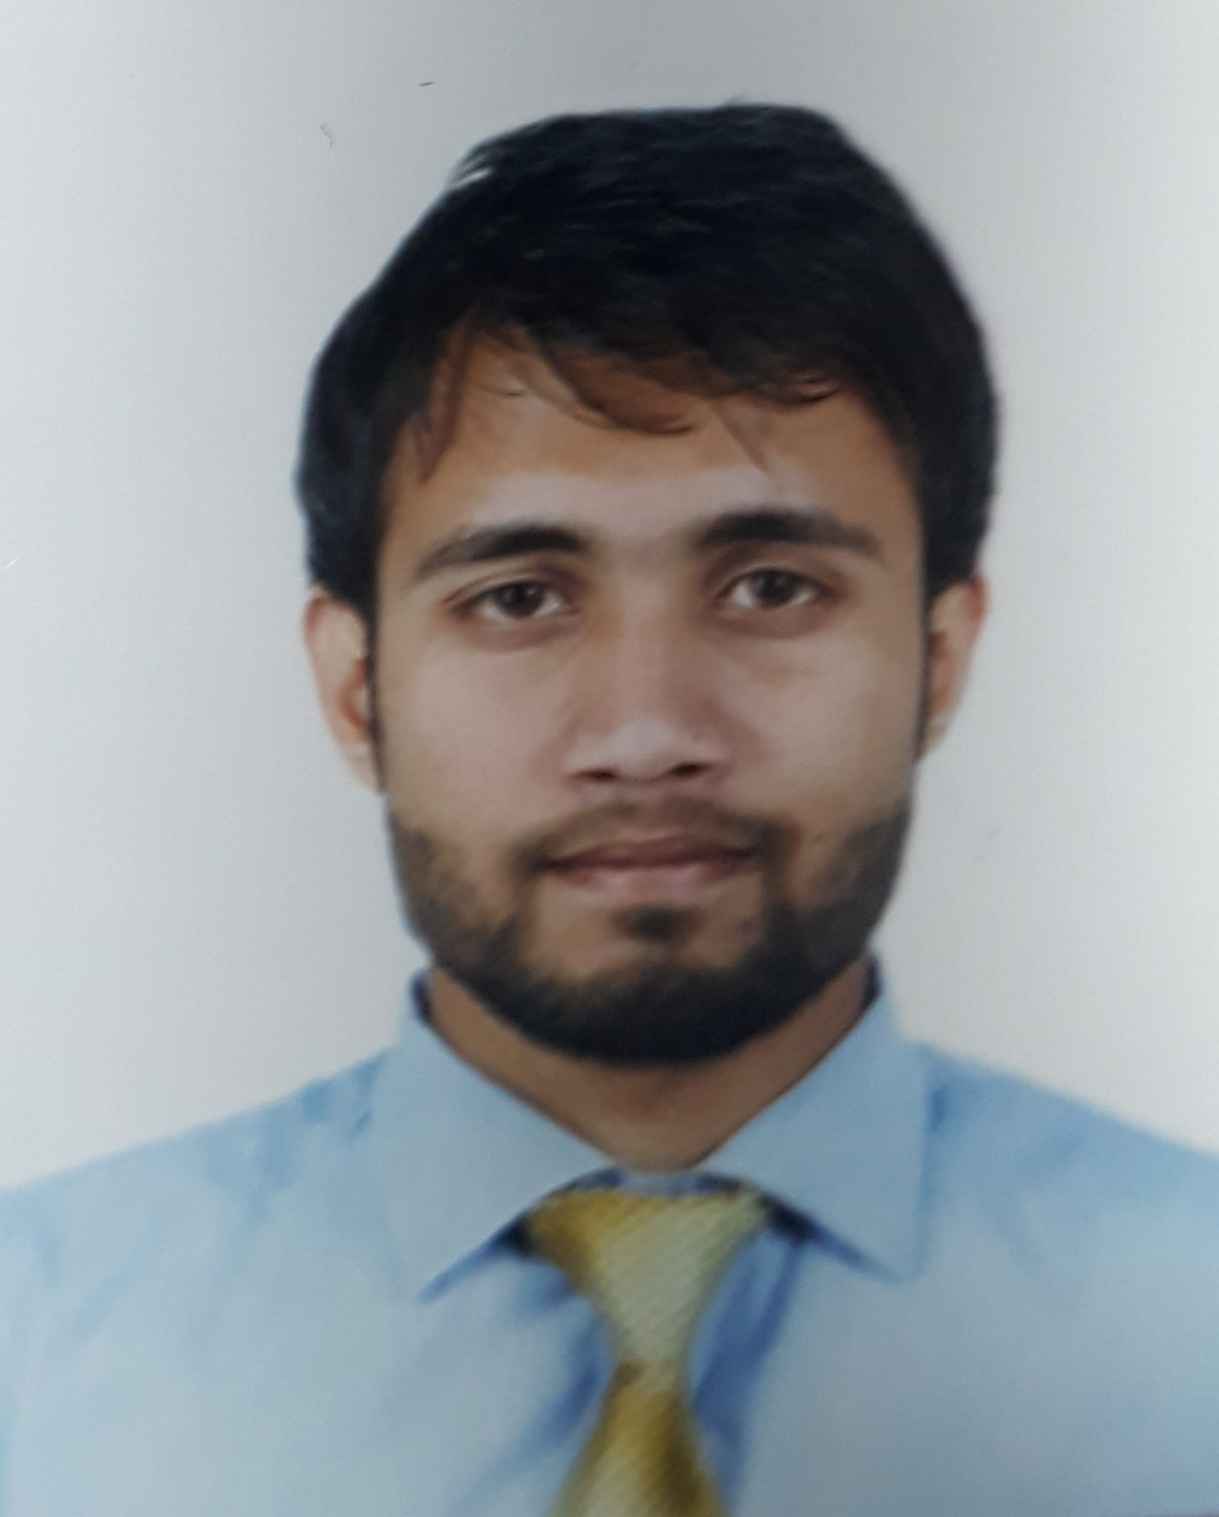 |  |  |  | AMAN  MALVIYA

Experience

- National agricultural development company Pvt. Ltd.
(Nadec) Riyadh Saudi Arabia(Sales merchandiser)
- 2020-2024

- 2018-2019 (sales support executive)
- Jc venture pvt ltd.
- 2017-2018 (Business development executive)
- Dhl Infrabulls pvt ltd.
- 2014-2019 (Manager)
- Clothing retail shop business.
- 2013-2014(customer support executive)
- bpo

Thinking, Planning, Initialization & Orientation due to Applying Knowledge, Skills & devotion toward job. I able to Attaint the Goal of organization and make growth of organization and myself also, as per my role in the organization.

Education
Bachelor of arts
HRSS, Indore Madhya Pradesh
- Diploma in computer application with first division marks.

Communication
- Writing.
- Speaking.
- Presenting.
- Listening.
- Negotiating.
- Team building.

Leadership
- Analytical Decision Making. ...
- Communication. ...
- Delegation. ...
- Teamwork. ...
- Adaptability. ...
- Creative Problem-Solving. ...
- Trustworthiness. ...
- Tech Savviness.

Hobbies
 |  | 85 Mishra Nagar Annapurna main road Indore 452009
 |  | Contact number-+916264118278
 |  | Aman.malviya7@gmail.com
- Gyming.
- Bike riding.
- Yoga.

Personal Information

- Father’s Name : Mr. K.K Malviya
- Gender : Male
- Date of Birth : 19/06/1992
- Languages Known : Hindi, English
- Marital status : Unmarried.

Declarations

I certify that all statements made by me are true, complete and correct to the best of my knowledge.
PLACE ……………
DATE ………………… (AMANMALVIYA)

