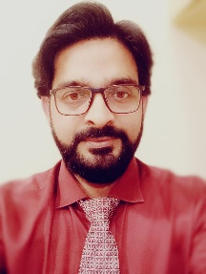Determinate to work for a challenging and progressive job with an esteemed organization offering good future prospects and professional working environment.

 **Skills**

MS Office

Hardware

Email

Administrative

Management

Operational

Communication skills

Reporting

Listening

Meeting

Teamwork

Training Programs

Travel arrangements, etc..

 **Work History**

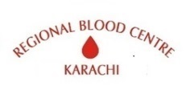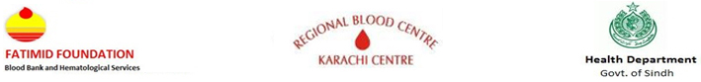

**2019-11- Departmental** **Secretary and HR Officer**

**Current** Regional Blood Center Karachi

Coordinate arrangements for internal and external meetings, and assemble appropriate material for the meetings/conferences/ social media.

• Daily follow-ups with interdepartmental on different assignments and update concern line manager.

* To resolve the complaints cleanliness as and where independently or escalate to concerned line manger
* To check all company vehicles regarding checklist o daily basis and maintain their log regarding maintenance of the vehicle.
* To coordinate with Manager HR & Admin to arrange candidate interviews.

• Coordinate the diary, and schedules, and coordinates travel arrangements for the concerned line

manager.

• Responsible for receiving incoming & and outgoing mail and maintaining their records.

• Independently ensure and supervise respective filing systems efficiently.

• The incumbent must be able to maintain a high level of confidentiality, tact, and decisiveness while working under the pressure of constantly changing priorities, unanticipated urgent demands, and multiple tasks and projects with competing deadlines.



**2019-02-** **Manager Administration**

**2019-11** Karachi psychiatric Hospital

• Daily follow-ups with Maintenance and Housekeeping Departments and clinics and Pharmacy department or canteen other departments also

• Meeting with supervisor and staff regarding any issue related to OPD or Clinic, duty roster.

• If anything is required for hospitals or clinics prepare a purchase order (PO).

• Hiring and training administrative staff

• Delegating tasks to administrative assistants

• Maintaining all policies and procedures manuals

• Delegating tasks to administrative assistants

• Performed monthly inventory and maintained office and medical supply counts.



**2017-09- Receptionist / Admin & Insurance officer**

**2018-11** Top Care Medical Center (Abu-Dhabi. UAE)

• Greet and welcome Patients/visitors as soon as they arrive at the medical center

• Answer, screen, and forward incoming phone calls

• Ensure the reception area is tidy and presentable, with all necessary stationery and materials (e.g., pens, forms and brochures)

• Provide basic and accurate information in person and via phone/email

• Receive, sort, and distribute daily mail/deliveries

• Checking Insurance eligibility through a web portal

**2012-01 Program Assistant, Admin Officer & OPD In charge**

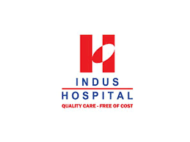**2017-08** The Indus Hospital Karachi

**2007-11- OPD Supervisor**

**2012-01** The Indus Hospital Karachi

• Make sure all clinic staff members are punctual and performing their duties properly.

• Request and arrange all clinic, office supplies, or equipment.

• Managing reporting and receiving of all clinic supplies and/or equipment.

• Maintain Consultants O.P.D in the shift.

• Responsible for updating and sending records regarding MIS error reports whenever required

• Coordinating and enforcing smooth and proper functioning of all activities at the Ghori ID Clinic.

• Responsible for making weekly requests for patients’ food baskets. Making sure all items in the food

store have been received.

• Responsible for making weekly requests for drugs, receiving them at the clinic, and monitoring

disbursement.

• Maintaining appointment lists for all DOT patients.

• Taking up all facility, clinic, and office maintenance issues directly with the various hospital departments.

• Focal person for receipt of DOT’s medication at the PTP center.



**2005-12- Receptionist cum Cashier**

**2007-06** Chinot General Hospital

• Responsible for monitoring of storage and their arrangement.

• Updating the management about working on a daily basis.

• Maintain record up to date



**2016-09-** **Restaurant Manager**

**2017-08** The Fat Burger (Hyper star Dolmen mall food court)

• Responsible for monitoring of storage and their arrangement.

• Updating the management about working on a daily basis.

• Maintain record up to date

**2015-06 Shift Manager**

**2016-09** Italiano food Lazzaro Restaurant (Dolmen Mall Tariq Road Food Court) – Chef Tahir Chaudhry

• Responsible for monitoring of storage and their arrangement.

• Updating the management about working on a daily basis.

• Maintain record up to date

 **Education**

MAS Public Administration (one paper remain)

B.A (Economic)

Intermediate (Pre. Engineering)

Matric (Computer. Science)

Hotel Management Diploma (PITHM)



**Reading, Browsing, Cricket**

Reading: Books like Islamic stories & Quran.

Browsing: Internet likes new invention for creative ideas etc.

Cricket: Watching and playing