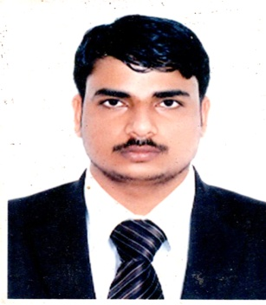

**CURRICULUM VITAE**

**MAHENDRA KUMAR**

Mobile: **+ 973 35920738**

Email: [mk001655@gmail.com](mailto:mk001655@gmail.com)

|  |
| --- |
| **CARRIER OBJECTIVE** |

To work as an efficient team player and to get a challenging carrier by exploring my skills set and work for the development of the organization.

|  |
| --- |
| **Personal Profile:** |

Name : Mahendra Kumar

Date of Birth : 05.07.1982

Sex : Male

Nationality : Indian

Marital Status : Married

Languages Known : Hindi, English, & Arabic

CPR No : 820765740

**Passport Details**

Passport No : P 4952602

Date of Issue : 10.10.2016

Date of Expiry : 09.10.2026

|  |
| --- |
| **EDUCATIONAL QUALIFICATION:** |

* **Master of Arts (English)**

|  |
| --- |
| **WORK EXPERIENCES:** |

* Worked as a **“Salesman”** with **“Al Sawalehi Garments”** in U.A.E Dubai (2007 to 2011) – 4 Years Experience
* Worked as a “Salesman: with **“Fatima Super Market”** in Oman (1Year Experience)
* Worked as a **“Salesman”** with **“Simple Trading”** in Kingdom of Bahrain (1 Year Experience)
* Worked as a **“Receptionist”** with **“Rotana Laundry”** in Kingdom of Bahrain (1 Year Experience)
* Worked as a “Receptionist” with **“Suraj Travel”** in India (2 Year

Experience)

* Worked as a **“Receptionist”** with **“Hend Travel”** in India (1 Year Experience)

|  |
| --- |
| **computer skill:** |

* Ms – Office Excel

|  |
| --- |
| **declaration:** |

I hereby declare that all the above information are true and correct to the best of my knowledge and belief.

Place: Bahrain. **MAHENDRA KUMAR**