Mark Lester C. Guingguing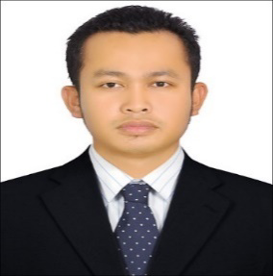

Mahimat tower, Hamdan street

Abu Dhabi, United Arab Emirates

Contact Number +571522952312

Email: [marky4280@gmail.com](mailto:marky4280@gmail.com)

________________________________________________________

**CAREER OBJECTIVE:**

To Obtain a position not only in my field of expertise but also in any field that will fit my qualifications for further development of my talents and skills.

To work in a company that would make full use of the knowledge and skills I have acquired through the years of experience, and provide me with an opportunity to learn more for future career advancements.

**QUALIFICATION:**

* + Graduated as Barista at Global Torch Institute Abu Dhabi, UAE.
  + Over 6 years’ experience as Merchandiser in FMCG and 3 years in Housekeeping Industry in UAE.
  + Flexible and hardworking.
  + Self-motivated and fast learner.
  + Able to work independently with minimum supervision.
  + Well oriented in customer service organization.

**WORK EXPERIENCE:**

**Thani Murshid Trading Company LLC**

**Merchandiser**-(December 18, 2016- November 21,2023)

* Make sure the availability and visibility of the products.
* Maintain FIFO/FEFO
* Make LPO/Orders for Local Delivery of Stocks.
* Check the price labels daily for price changes.
* Check for near Expiry.
* Maintain cleanliness of displays.
* Ensure proper Planogram is Implemented with correct POSM.

**Cleaner/Housekeeping Galleria Mall-MBM (Model Building Maintenance)**

(June 25, 2013 to October 2016)

* Assist guests in food court.
* Cleaning tables and chairs before and after the guests.
* Maintain the cleanliness and orderliness of the food court.
* To maintain the cleanliness of the Hallway at all times particularly the floors, glass, steels, sofas and carpets.

**EDUCATIONAL BACKGROUD:**

**Vocational:**

Course: Office Management with Computer Application.

Name Of School: Misamis Occidental Technological Institute.

**PERSONAL INFORMATION:**

Age 35

Gender Male

Date of Birth July 11, 1988

Religion Roman Catholic

Nationality Filipino

Marital Status Single

Dialect Spoken English, Filipino

Visa Status Cancel Visa

*I hereby Certify that the information above is true and correct to the best of my knowledge.*

**Mark Lester C. Guingguing**

Applicant