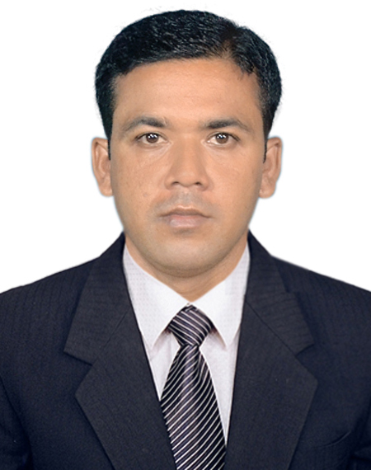
CURRICULUM-VITAE
OF
MD. ABDUL WAHED

Contract Address: Contact:
C/O: Md. Shefaeat Ullah Mobile: +971 56 874 6707
E-mail: wahed2945@gmail.com
Vill: Chandutia, P.O: Chandutia -7407, P.S: Kotwali, Dist: Jashore.

Career Objective:
To obtain a challenging job where I can execute my potentiality, intellectuality and adaptability to do something innovative and creative not merely to achieve organizational goals but also to enhance my professional skills and ability.

Academic Qualification:

Bachelor of Business Administration (B.B.A)
Subject : Finance
University : Darul Ihsan University
Result : 3.61 out of 4
Year of Passing : 2013

Higher Secondary Certificate (H.S.C)
Group : Business Studies
G.P.A : 4.62 out of 5
Name of Institution : Jashore Technical & Management College, Jashore.
Board : Technical
Year of Passing : 2008

Secondary School Certificate: (S.S.C)
Group : Electronics.
G.P.A : 3.81 out of 5
Name of Institution : Munshi Meher Ullah Academy.
Board : Technical
Year of Passing : 2006

Experiences:
Marketing Officer ( December 11, 2017 - November 04, 2020)
PRAN RFL Group
Narail, Khulna
Accounts Officer (November 14, 2020 - Running)
The ACME Laboratories Ltd
Jashore Depo

Computer SkillComputer Office Application, Internet browsing, etc.

Language Skill:
Language | Writing | Reading | Speaking
Bengali | Excellent | Excellent | Excellent
English | Good | Good | Good

Hobbies and Interests:
- Traveling, Reading Books, News Paper, Playing
Specialty:
- Communicative & friendly
- Ready to work with a stress worth environment
- Ability to manage things and work with group
- Like to take challenges

Personal Information:

Name : Md. Abdul Wahed
Fathers Name : Md. Shefaeat Ullah
Mothers Name : Mst. Hasina Banu
Permanent Address : Vill: Chandutia, P.O: Chandutia -7407,
P.S: Kotwali, Dist: Jashore.
Date of Birth : 15/03/1991
Nationality : Bangladeshi (By Birth)
Religion : Islam
Marital Status : Unmarried
Sex : Male

Declaration:
I do hereby declare and certify that all information stated above is true and complete to the best of my knowledge and belief.


Date: 20/03/24 Signature

.....................................

Md. Abdul Wahed

