MEENAKSHI.S

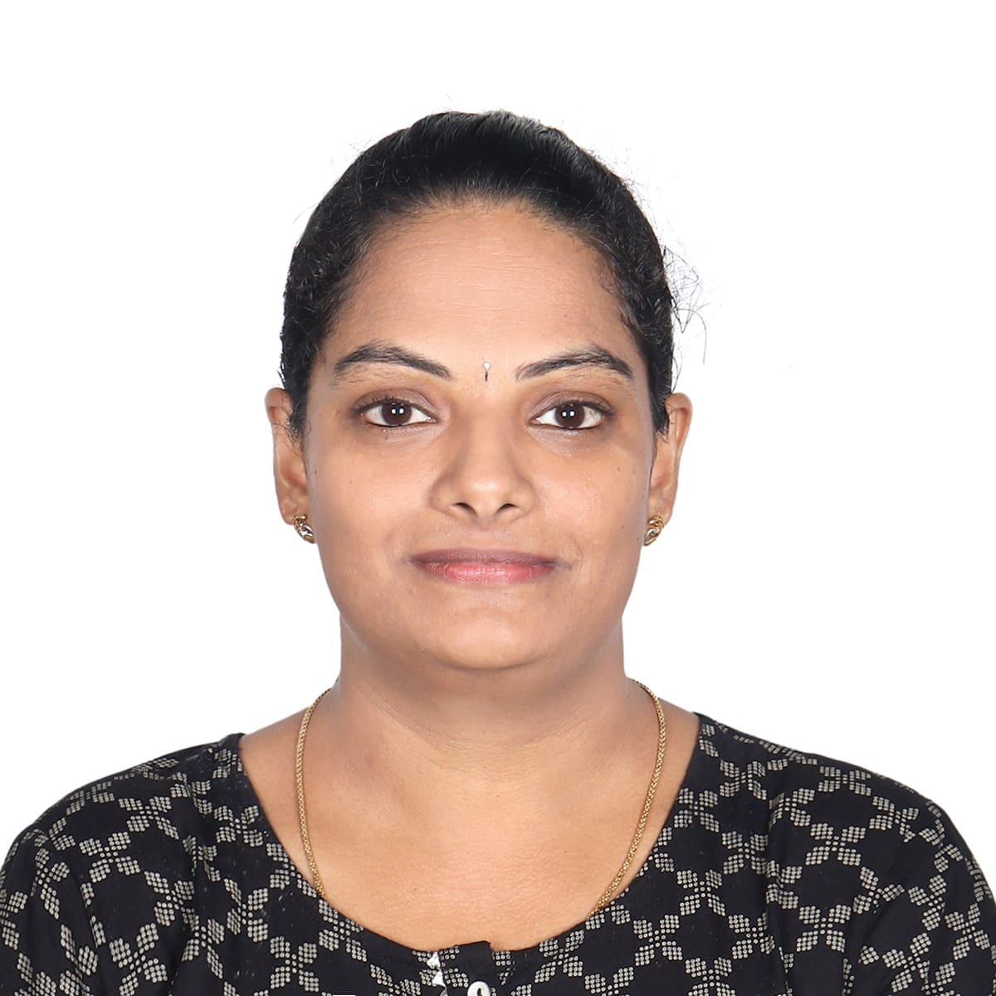

# PROFESSIONAL SUMMARY

Intend to build a career in a reputable organization, by utilization of my skills and knowledge with quality of administration & execution, for achieving the assigned goals and contribute to organizational growth along with personal development.

# PROFESSIONAL EXPERIENCE

## Diamond Shipping Services LLC Feb 2013- Nov 2022

* ***Customer Service (LCL EXPORT & IMPORT)***

## Sales Coordinator

## Inside sales

***Roles & Responsibilities***

* *Prepare & update various pricing requests that support & maintain current clients as well as strategize on acquiring new businesses.*
* *Work on pricing with department managers & other sales personnel throughout with multiple carriers & other offices globally with rate request.*
* *Analyze past, present & future market rates to help strategize for new client.*
* *Analyze cost, profit & market value to help maintain company growth*
* *Work closely with operational & overseas offices on space allocation for quoted carriers.*
* *Carefully monitoring market trends to ascertain best pricing for company products*

## Customer Service

* *Develop & understanding of such customer needs & take actions to ensure such needs are met.*
* *Deal with a high volume of inbound & outbound phone calls.*
* *Maintain relationship with carriers & customers*
* *Provide exceptional service to customers.*
* *Provide shipment quotes for customers & setup shipments as required by customers.*
* *Complete booking with carriers & submission of shipping instructions with great accuracy.*

# CONTACT INFORMATION

**Mobile**

***+*971 559289248**

**Email**

[*meenakshimoorthy8@gmail.com*](mailto:meenakshimoorthy8@gmail.com)

**Address Dubai, UAE**

# ACADEMIC QUALIFICATIONS

* ***Bachelor of Science***

Madras University

* ***Secondary School Education***

Angel matriculation matric school

Karnataka Sangha Hr.sec school

# PERSONAL STRENGTH

* *Possess good verbal & written communication skills, Interpersonal skill.*
* *High level of confidence and leadership oriented.*
* *Team facilitator & able to deal with people in a diverse environment.*
* *Ability to maintain confidentiality.*
* *Willing to learn on the job and receive additional hands-on training.*

•

•

•

**PERSONAL INFO**

*Date of Birth : 04/ 02/ 88*

*Nationality*

*Visa Status*

*: Indian*

*: Firm*

**SPECIALIZED SKILLS**

* *Knowledge of basic use of computer, MS Word, MS Excel, MS PowerPoint and MS Outlook.*
* *Business Logistics.*

**LANGUAGES**

* *English*
* *Tamil*
* *Hindi*

## Sales Coordinator

* *Coordinate sales team by managing schedules, filing important documents & communicating relevant information.*
* *Respond to complaints from customers & give after-sales Support when requested.*
* *Inform clients of unforeseen delays or problems.*
* *Helping the sales team to improve their productivity by Contacting customers to arrange appointments & ensuring all sales representative have high quality, up-to- date support material.*

# DECLARATION:

I hereby declare that the above-mentioned particulars are true to the best of my knowledge.