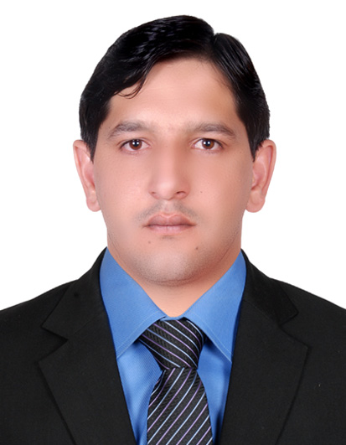
Azhar Mehmood

Cell #: +971-501653491 052-1305006

Passport # PR0156641

E – Mail : mughalazhar261@gmail.com
Visa: Employment Visa
Marital Status: Married

PROFILE
AT A GLANCE
- Experienced in developing and implementing competitive plans.
- Proven ability to maintain Good Performance under Pressure.

OBJECTIVE
To obtain a challenging position in a reputed organization, offering opportunity for personal growth and career development and to become a part of a highly motivated and dynamic team of professionals with a result oriented and forward looking approach.

KEY COMPETENCIES
- Quick learner.
- Hardworking
- Self confident, self initiative.
- Excellent in communication and interpersonal skills.
- Able to work in multi-cultural environment.
- Able to manage time, prioritize tasks, and meet deadlines.
- Ability to adjust to a rapidly changing work environment.
- Flexible, work extremely well with co-workers.

EXPERIENCE

SECURITY Guard

Worked as Security Guard at Knight Bridge Global Security Dubai U.A.E.(May 2012 to June 215)

Worked as Cash and Transit Transguard Group UAE (2016 to till Now )
Accountant

Worked as Accountant at Human Appeal International Pakistan.

(Jan 2007 to Feb 2010)
Worked as a Driver with Transguard Group LLC, Dubai in UAE for 3 years.

Customer Services
Worked as Customer Services at Al Baraha Hospital In Dubai UAE for 01 Year .

Educational Background
- Graduation
B.A
(2008-2010)
(AJK University)

- Intermediate
I.Com
(2005-2007)
( Mirpur BISE AJK)

- School Certificate
Matriculation
(2004-2006)
( Mirpur BISE AJK)

Personal Data

- Father’s name Muhammad Azad Khan
- Date of Birth 07-01-1987
- Religion Islam
- Nationality Pakistani
- NIC # 82102-4746664-5

Computer Skills

- Proficient with MS Office
- Internet

Interests

- Participation in adventure activities
- Games
- Surfing internet
- Helping humanity

References

Will be furnished on demand

