**Curriculum Vitae**

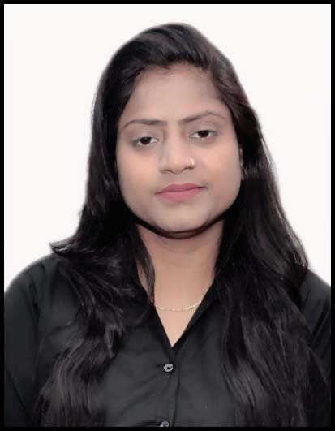

**Miss. Priya**

**Mob: +971545125455,**

**Email:** [**sunny0545125455@gmail.com**](mailto:sunny0545125455@gmail.com)

**Priyasharma995527@gmail.com**

**Dubai– UAE**

**APLYING FOR THE POST FOR -CASHIER /SALESMAN/STOKER**

**Objective**

To serve the organization with my best of my effort keeping its objectives in mind and thereby developing my own knowledge, skills and capabilities of the maximum. Eager to learn and ready to work hard to attain customer satisfaction through the utilization of my dynamic and warm personality and customer service protocols.

**Work Experience**

**Company - CIVIL DEFENCE CORPS DELHI**

**Position Held -** Volunteer (Payable)

**Duration -29 OCTOBER 2020 TO 14 MARCH 2023**

**Country - SOUTH DELHI, India**

**Duties & Responsibilities**

* Direct visitors to the appropriate person and office.
* Ensure reception area is tidy and presentable, with all necessary stationery and material (e.g. pens, forms and brochures).
* Provide basic and accurate information in-person and via phone/email.
* Maintain office security by following safety procedures and controlling access via the reception desk (monitor logbook).
* Order office supplies and keep inventory of stock.
* Arrange internal and external transportations for school events, activities, trips, guests, etc.
* Perform other clerical receptionist duties such as filing, photocopying, etc.
* Perform all other ad hoc tasks assigned by the line manager.

**Education academic & technical**

* Senior **Secondary Passed** with First Division.
* Completed **CIVIL DEFENCE** **TRAINING** from Director of Civil Defense Delhi. (Actively Member.
* **Passed o level** computer operator certificate*. (Waiting for certificate)

**Skills**

* Public speaking.
* Well knowledge About Fire warden Responsibilities.
* Hands-on experience with office equipment (e.g. Printers).
* Professional attitude and appearance.
* Ability to be resourceful and proactive when issues arise.
* Excellent organizational skills.
* Multitasking and time-management skills, with the ability to prioritize tasks.
* Customer service attitude.

**Passport Details**

* PASSPORT STATUS  **ECNR**
* PASSPORT VALIDITY 25 JULY 2032
* ISSUED PLACE Delhi INDIA
* VISA STATUS **VISIT VISA** (VALID UNTIL 05 MAY 2023)

**Conclusion:**

I hereby certify that the above information is true and correct according to the best of my knowledge & My Experience. If selected I assure that I would perform to the best of my abilities, early awaiting a Positive response.

DATE **19/03/2023 Miss priya**