Curriculum Vitae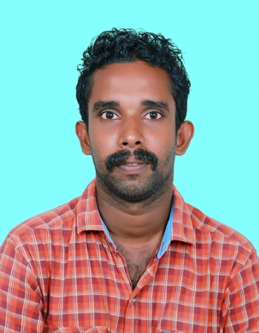

**RAHUL.S**

**NEELIPARAMBIL**

**PATHIRAPPALLY P.O**

**POOMKAVU**

**ALAPPUZHA**

**PINCODE: 688521**

**KERALA**

**EMAIL-ID:rahulsasankan123@gmail.com**

**PHONE: 7736291362, 7012938450**

**CARREER OBJECTIVE**

TO ACHIEVE A RECONIZING IN A REPUTED AND PROGRESSING WHERE I CAN IMPROVE MY SKILLS AND KNOWLEDGE FOR MY PERSONAL DEVELOPMENT AND THE BETTERMENT OF THE ORGANISATION**.**

**EDUCATIONAL QUALIFICATION**

|  |  |  |  |  |
| --- | --- | --- | --- | --- |
| **SLNO** | **QULIFICATION** | **SUBJECT** | **BOARD&UNIVERSITY** | **PASSED** |
| 1 | DEGREE | B.COM | KERALA UNIVERSITY | Complete |
| 2 | PLUS TWO | COMMERCE | KERALA BOARD OF HIGHER SECONDARY EXAMINATION | 2013 |
| 3 | S S L C | GENERAL | KERALA BOARD OF PUBLIC EXAMINATION | 2011 |

**DRIVING LICENSE**

**LMV,MWG**

**TECHNICAL QUALIFICATION**

TALLY

MS OFFICE

**EXPERIENCE**

PRE EXPERIENCE IN JHONS UMBERLLA GODOWN SECTION SUPERVISOR POST FOR 1 YEAR

WORKED AS AKSHYA CENTER STAFF FOR 2 YEAR

WORKED AS KITEX CHILDRENSWEAR FOR 6 MONTHS

**LANUAGE KNOWN**

ENGLISH, MALAYLAM

**PERSONAL COMPETENCIES**

* PUNCTUALITY
* HONESTY
* HARDWORKING
* SINCEREIT

**PERSONAL DETALIS**

NAME : RAHUL S

FATHER’S NAME : SASANKAN R

GENDER : MALE

DATE OF BIRTH : 23.01.1995

AGE : 26

RELIGION : HINDU

NATIONALITY : INDIAN

MARTIAL STATUS : SINGLE

**HOBBIES**

* WATCH VIDEO
* MUSIC
* TRAVELING

**DECLARATION**

I HEREBY THAT ALL THE ABOVE FURNISHED INFORMATION IS TRUE TO THE BEST OF MY KNOWLEDGE AND BELIEF. I WILL DO THE WORK SINCERELY FOR THE COMPANY

DATE :07.06.2022

PLACE :ALAPPUZHA RAHUL S