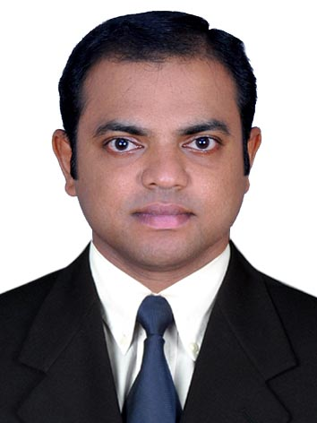
RAJEEV MADHAVAN
Gokulam, Pottayil,
Malayinkeezhu P.O
Trivandrum-695571
Kerala, India
Mobile:- 9289746490
E-MAIL: rajeevmadhav634@gmail.com

CAREER OBJECTIVE

To obtain a sales position with a progressive organization, where my contribution of motivational and leadership qualities will positively affect and add value to the organization.

WORK EXPERIENCE

Worked as Executive Accounts in Flights Guru Infotech Services PVT Ltd,

New Delhi India from 13th December 2021 to 31st August 2022.

Worked as Sales Executive in Gettco International, Doha Qatar from October 2010 to April 2020

JOB RESPONSIBILITY INVOLVES:

- Services Existing accounts, obtain orders, and establishes new accounts by planning and organizing daily work schedule to call on existing or potential sales outlets and other trade factors.
- Adjusts content of sales presentations by studying the type of slaes outlet.
- Submits orders by referring to price lists and product literature.
- Keeps Management informed by submitting activity and results reports, such as daily call reports, weekly work plans, and monthly and annual territory analyses.

Worked as Organized Trade Sales Executive (in Consumer Division) in National Trading & Developing Est. (NTDE), Dubai, UAE from April 2006 to January 2009.

Job Responsibility Involves:

- Achieving sales target
- Taking orders, collection monitoring sales performance and solving problem related to my outlets.
- Daily Sales Report to Supervisor – Key Accounts
- Responsible for the display in the Key Accounts as per the instructions given by Supervisor
- Co-ordination with Merchandisers & Shelf Fillers
- Report the Competitor Activity in the market (Consumer Promo & Trade offers)
- Group of outlets handled in Dubai are ( Carrefour, Union Coop, Lulu, Spinneys, Choitharam, Al Maya, Grand, Madeena, Talal etc)

Al Owaid Trading & Transporting Co. Dubai January 2004 to September 2005 Sales Representative

Duties and Responsibilities
- Involved in sales of perfumes and cleaning items.
- Identifying potential future customers.
- Involved in negotiating and closing the deal.
- To keep track of competitors activity and price changes.

Centurion Bank of Punjab, India October 2005 to February 2006
Field Investigation Co-ordinater

Duties and Responsibilities

- Involved in sales and co-ordination.
- Customer price and credit period negotiate.
- Clearing customer application form.
- Cost calculations, negotiating and closing deals

ACADEMIC QUALIFICATION

- Secondary School Leaving Certificate from Kerala, India.
- Pre-Degree course from Kerala University, India.

COMPUTER SKILLS

- Data entry and Consol operation Certificate, India
- C-DAC, GIST, Pace Program Certificate, India
- MS-Office Certificate from Atlas Education Institute, Dubai

PERSONAL DETAILS

Nationality : Indian
Gender : Male
Marital Status : Married
Date of Birth : 11-04-1982
Passport No : K 1680740
Visa status : Visit Visa ( 07-07-2016 – 02-10-2016 )
Languages Known : English, Hindi and Malayalam
Driving License : Holding a valid Indian Driving Licence (15-07-2002-21.07-2032) Holding a valid UAE Driving License (02/08/2004 – 03/08/2024) Holding a valid Qatar Driving License (21/12/2010-14-12-2025)

STRENGTH

- Self motivated
- Ability to work under pressure
- Very strong customer relationship
- Hard work and Sincerity
- Multi tasking easily handled
- Burning desire for self improvement
- A good team player and positive attitude
- Ability to strike a friendly chord with any kind of personality and versatility.

