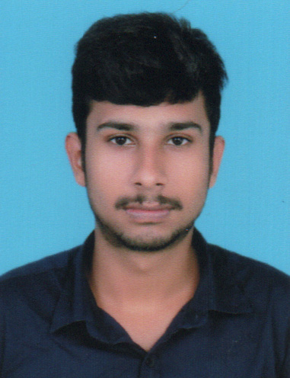
Curriculum Vitae
SALEEM S
Charuvila Puthen Veedu
Kuzhivilakarikkam
Samnagar P O
KULATHUPUZHA
Kollam - 691310
Contact No # 9567487828
Email ID: saleemsamnagar2000@gmail.com

PERSONAL DETAILS

- Name : SALEEM S
- Name of father : Sainulabdeen
- Name of Mother : Latheefa
- Nationality : Indian
- Date of Birth : 26-07-2000
- Sex : Male
- Marital Status : Single
- Religion : Muslim
- Language Known : Malayalam, English

EDUCATION QUALIFICATION

- S.S.L.C : Kerala Board of Public Examination
- Plus Two : Kerala Board of Higher Secondary Education
- B.com(Finance) : University of Kerala
- Tally : Council for Technical Education

INTERPERSONAL SKILL

- Ability to adapt and cope up with different situation, surrounding and culture.
- Ability to rapidly build relationship and set up the trust.
- Honest and Sincere.

DECLARATION:

I do hereby declare that the above mentioned data are correct and true to the best of my knowledge and belief.
SALEEM S
Place :
Date :

