* 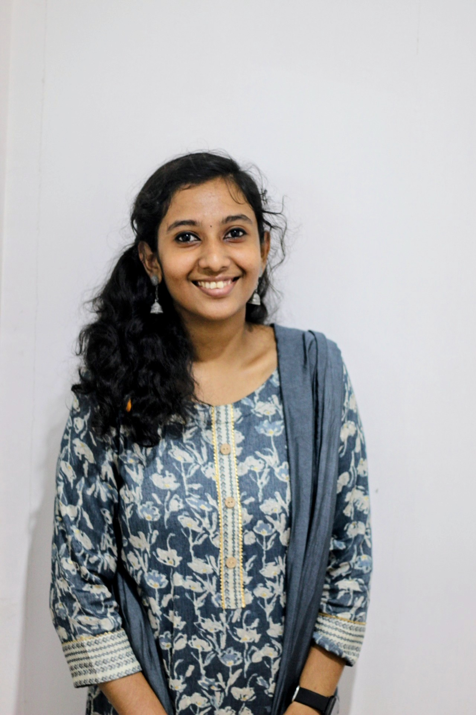Receiver with solid fill

**CGA**

**(Tally Essential, Excel, Gcc Vat)**

*G-Tech Computer education,Kottayam* **July 2023 - Dec 2023**

**Bachelor of Commerce Nov 2020 – May 2023**

*Kuriakose Elias College, Mannanam*

*(Mahatma Gandhi University)*

**G.S.T & Income Tax Jul 2021 – May 2023**

*Kuriakose Elias College, Mannanam*

**Higher Secondary Jun 2018 – Mar 2020**

*St.Aloysius HSS, Athirampuzha*

**Board Exam Apr 2017 – Mar 2018**

*St Mary's GHS, Athirampuzha*

**Susmi Mohan**

Education

* *Seeking a challenging position in a reputed organization where I can learn new skills, expand my knowledge, and leverage my learnings.*
* *To get an opportunity where I can make the best of my potential and contribute to the organization's growth.*

**Work Experience**

Accounts Assistant /Junior Accountant- Butterflies Store

Kottayam, Kerala June 2022- November 2023

: Managed the accounts payable and accounts receivable processes for a small

Business.

: Prepared financial statements and reports, such as balance sheet and store

Ledger.

: Analysed financial data to identify and resolve discrepancies.

: Provided support to the accounting by filling necessary documents.

: Reviewed and processed invoices for payment.

**References**

References available upon request.

Certificates

**National Service Scheme Aug 2018**

*Three Day State Level Volunteers Leadership Training Camp*

**Awake 2022 Jul 2022**

*As a Volunteer Leader in State Level Cultural Fest for Differently Abled*

**GIIMS Mar 2023**

*All Kerala Best Manager Contest- Season 8*

Career Objectives

* English
* Malayalam
* Tamil

M

[susmimohan1126@gmail.com](mailto:susmimohan1126@gmail.com)

+971555800603

+91 7736272537

Olarattu (H)

Sreekandamangalam P.O

Kottayam, 686562

November 26, 2002

Female

Word

Excel

Presentation

Tally Essential

Programming

GCC VAT

Languages Known



Skills

Personal Details

**Pratheesh .C**

*Asst. Professor*

*Kuriakose Elias College, Mannanam*

Mob: +91 9496115415

Email: [pratheesh@kecollege.ac.in](mailto:pratheesh@kecollege.ac.in)

**Geethika Suresh**

*Asst. Professor*

*Kuriakose Elias College, Mannanam*

Mob: +91 8547564925

Email: [geethikasuresh@gmail.com](mailto:geethikasuresh@gmail.com)

More References available upon request.

Achievements

* *Completed project work submitted on behalf of Mahatma Gandhi University based on the topic "A STUDY ON WOMEN ENTREPRENEURSHIP WITH THE SPECIAL REFERENCE TO KOTTAYAM MUNICIPALITY".*

**National Service Scheme 2018 – 2020**

*St. Aloysius HSS, Athirampuzha*

*Special Camping Programme from 22/12/2018 to 28/12/2018 at St. Ephrems HSS, Mannanam. No. of hours of service done: 240*

**Kerala Startup Mission Oct 2021**

*Kuriakose Elias College, Mannanam*

*Hortari Community*

**Intellectual Property Rights Jul 2022**

*Kuriakose Elias College, Mannanam*

**National Service Scheme 2020 –2022**

*Kuriakose Elias College, Mannanam*

*Special Camping Programme from 12/02/2021 to 18/02/2021 at Online.*

*No. of hours of service done: 240*

* Dedication
* Leadership Qualities and Teamwork
* Verbal and written Communication
* Time Management
* Digital Marketing
* Adaptation
* Hard Working

Extracurricular Activities

Operating Systems

Technical Skills

Qualities

* C++
* HTML
* M.S Office
* Excel
* Windows
* IOS
* Ubuntu

References