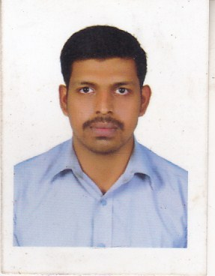

**CURRICULUM VITAE**

**VINESH .V .V**

**India**

**MOB No : +91 9578317859**

**Emil id:** [**vvvines95@gmail.com**](mailto:vvvines95@gmail.com)

**Passport Number: V5760692**

**PERSONAL DATA**

Date of Birth : 26.04.1994

Sex : MALE

Father’s Name : K.Vincent

Nationality : Indian

Marital Status : Single

Languages known : Tamil , English , Malayalam,

**Permanent Address** : Mulaikkavilai,

Malaicode,

Edaicode post,

Kanya Kumari Dist,

Tamil Nadu – 629152

Mobile : +91 9578317859

**TECHNICAL QUALIFICATION**

* **Tally**
* **Java**
* **Ms Office**
* **C, C++**

**CAREER OBJECTIVE**

To obtain a qualified position in your company indulge professional growth as well as challenging and rewarding environment which provides brain thrust ,resource stimulation and offering varied responsibilities that could broaden my technical and in return will bring satisfaction to the company

**STRENGTHS**

* Positive attitude toward work
* Hard working
* High sense of commitment and dedication
* Ability to learn and adopt new technologies fast
* Local thinking
* Strong work ethics
* Excellent in health likes to travel and willing to get relocated to any part of the country
* Dedicated result oriented/initiative and responsible natured.

**EXPERIENCE DETAILS**

* Four year experience as store manager in Nilas mobile show room (2016-2020)
* Two years experience as billing in ppn supermarket (2021-2022)
* 1 years experience as store supervisor in ppn supermarket (2023-2024)

**EDUCATION QUALIFICATION**

|  |  |  |  |
| --- | --- | --- | --- |
| **Course** | **Name of institution** | **University** | **Percentage%** |
| **SSLC** | G.M.H.S.S.  MARTHANDAM | State Board | 63% |
| **HSC** | H.F.H.S.S  MUKKUTTUKAL | State Board | 62% |
| **BSC COMPUTER SCIENCE** | PIONEER KUMARASWAMY COLLEGE NAGERCOIL | Manonmaniam University | 61% |

**DECLARATION**

I hereby declare that the information furnished above is true to the best of my knowledge and I bear the responsibility for correctness of the above mentioned particulars.

**DATE: / / Your’s faithfully**

**PLACE:** Malai Code (**VINESH V V**)