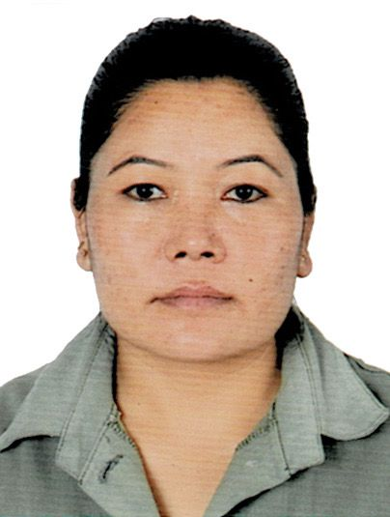 RUBI KHADKA   
 Discovery Garden, Street-3, Dubai, UAE   
 0581279249  
 rubi.khadka123@gmail.com

**PROFESSIONAL SUMMARY**

Honest Cashier skilled at managing money, merchandising stock, and assisting customers with locating desired items. Excellent oral and written communication, listening and time management skills with strong attention to detail and superior work ethic. Consistently accurate in drawer reconciliation.

Effectively meet front-end needs with skilled merchandising, customer support and register management. Proficient in processing purchases and returns with high accuracy and diligent attention to important details. Sales expert promotes products and plans to boost store profits.

**WORK HISTORY**

**Cashiers 07/2021 - 02/2023**

**Bhatbhateni Supermarket** - Kalanki, Kathmandu

* Manage transaction with customers using cash registers.
* Scan goods and ensure pricing is accurate
* Collect payment whether in cash or credit
* Issue receipts, refunds, change or tickets
* Cross- sell products and introduce new ones.
* Greet customers when entering or leaving the store.
* Maintain clean and tidy checkout areas
* Track transaction on balance sheet and report any discrepancies

**Receptionist 05/2015 -04/2017**

**Merit Institute** - Kalimati, Kathmandu

* Greeted incoming customers in professional manner and provided

friendly, knowledgeable assistance

* Answered and helped resolve enquiries from client, vendors and

general public

* Kept reception area clean and neat to give visitors positive impression

of the company

* Solved administrative and customers service issues with knowledgeable
* assistance and friendly support

**Education**

**Diploma :** Hotel Management **07/2009 – 04/2012**

**Shahid Smarak College -** Kritipur, Nepal

**Diploma of Education:** Hotel Management **02/2011 -08/2011**

**Nepal Academy Of Tourism And Hotel Management** - Kalimati, Kathmandu

**Personal Details**

Date of Birth April 28, 1990

Nationality Nepali

Civil Status Widower

Language English, Hindi & Nepali

**Passport & Visa Detail**

Passport Number 11813894

Date of Issue 12 Jan 2020

Date of Expire 11 Jan 2030

Visa Status Visit Visa

Visa Expiry Date 12 July 2024

