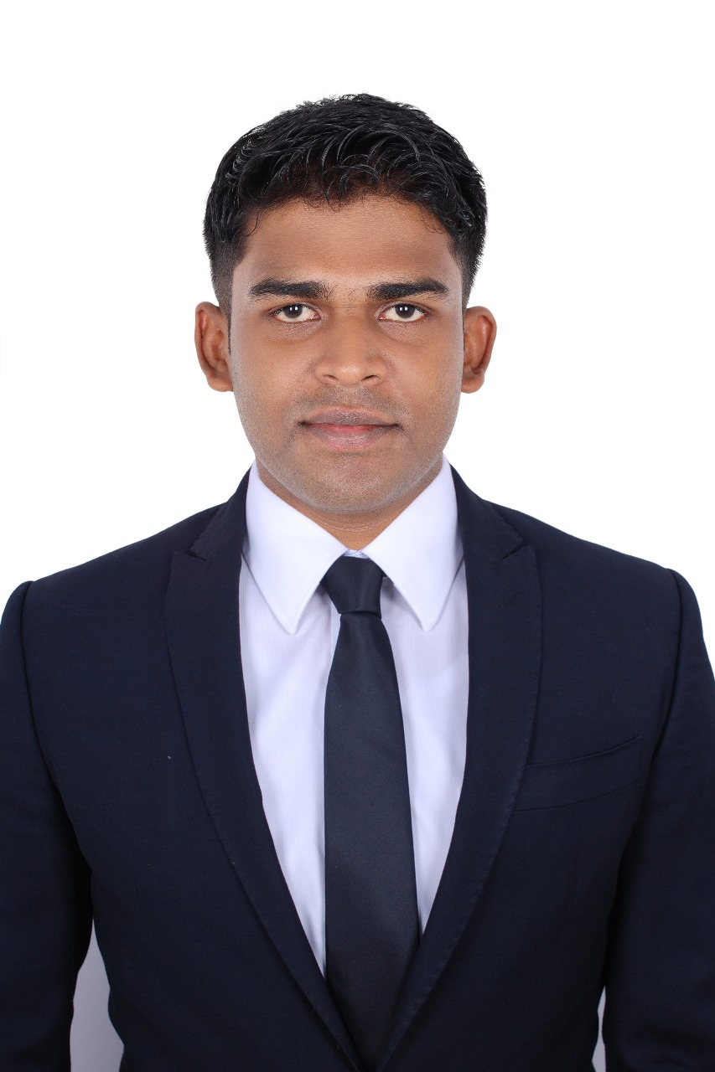 |  | Front office executive with 5 years of experience (Ready to join immediately)  Sachin kularathna
Objective  I am a hospitality sector employee with 5 years of knowledge and experience in reputed Restaurants, and hotels in UAE / SRILANKA, and looking for opportunities in any field  Contact  PHONE:  0558190556  EMAIL:  sachinravishana@gmail.com  ADDRESS:  SAL Aldin, Dubai, UAE  Personal Info  Full Name: Sachin Ravishana Kularathna  Date of Birth: 28th of December 1996  Nationality: Sri Lankan  Marital Status: Single  Visa status: Freelance visa  Professional Skills  - Quality Assurance  - Resource Management  - Conflict Resolution  - Analytical Skills  Computer literacy  - Microsoft Office package  languages  - English – Proficiency  - Sinhala – Native  - Tamil – Medium  - Japan -Medium |  | WORK EXPERIENCE  ALBAIK Restaurant /UAE  06/2024 – Present  Team member – Albaik restaurant UAE  - Greet guests upon arrival, providing warm and welcoming  service.  - Managed check-in and check-out procedures efficiently,  - ensuring accurate processing of guest information and  payments.  - Responded promptly to guest inquiries via phone, email, and in-  person, resolving issues to their satisfaction  - Acted as a liaison between guests and various restaurant  departments, coordinating requests for housekeeping,  maintenance, and other services.  Front office executive  Thilanka resort & spa / srilanka  04/2019 – 04/2024  - Manage front desk operations, including greeting guests,  - handling check-in and check-out procedures, and addressing  - guest inquiries and concerns.  - Coordinate reservations, ensuring accuracy and efficiency in  - booking processes and maintaining up-to-date room  - availability.  - Act as a point of contact for guest feedback and complaints,  - resolving issues promptly and effectively.  - Collaborate with colleagues to ensure smooth operations and  - uphold high standards of service.  - Assisted with administrative tasks such as answering phone  calls, responding to emails, and maintaining guest records  receptionist  camelia resort & spa /Sri Lanka  03/2017 - 02/2019  - Welcoming office guests and directing them to the person or office they visit.  - Answering and making phone calls on behalf of office employees.  - Handling office correspondence.  - Maintaining office supplies.  - Scheduling meetings for employees.  - Maintaining the reception area.  EDUCATION  Top-up degree in business administration  2024  Completed in 1 year in UCAM university and waiting for final results  Higher Diploma in business management  2021- 2023  Completed in 2 years academic period and 6 months internship period. Conducted by Cardiff Metropolitan University UK  Advanced diploma in business management  2020/2021  Completed in 1-year academic period, conducted by the National Institute of Business Management

