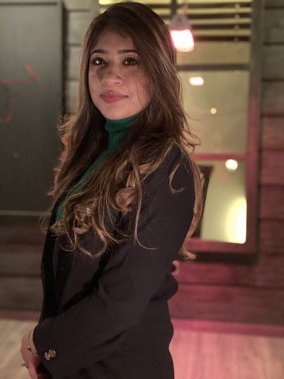

**Sadia Jaleel**

**+92 3139999254, sadiajaleel12@gmail.com, Lahore, Pakistan**

EDUCATION

**Pakistan Institute of Fashion and Design**, Lahore, Pakistan May 2020

*Bachelors in Gems and Jewelry Design* GPA: 3.2 *Relevant Coursework:**Gems Study, Handcraft, Design, Drafting, CAD*

**Lahore Grammar School,** Lahore, Pakistan May 2015

A’levels in Science

**Lahore Grammar School,** Lahore, Pakistan May 2013

O’levels in Science

WORK EXPERIENCE

**Nest Wood Reality,** Dubai, UAE October 2023 – March 2024

# Telesales Real Estate

* To bring in potential clients for buying off plan projects
* Close sales over the table
* Understanding the clients budget, requirements and finding the best deal

**Biz Ventures,** Lahore, Pakistan January 2021 – May 2023

# Director Business Development

* Proactively building company portfolio by bringing in potential clients
* Finance management inside the company
* Managing day-to-day operations, client investments, and monthly ROI
* Consulting with clients on best strategies for renewal of contracts
* Trading and teaching crypto
* Expanding existing portfolio through cross-selling collaborations across the sales team

**Western Union,** Lahore, Pakistan April 2020 – December 2020

# Customer Support

* Guide existing customers with their transactions
* Assist new customers with transactions.

**Digital Global Services,** Lahore, Pakistan July 2016 – May 2017

# Sales Executive

* Upselling existing clients by upgrading the deal
* Selling to new potential clients

**Fresh Paidel- Foundation for rehabilitation and education of slow children,** Lahore, Pakistan July 2015

# Accountants and additional activities

* Raised funds for the NGO
* Location visits to special schools
* Activities with the kids

**Fatima Memorial Hospital,** Lahore**,** Pakistan June 2015

* Visits to rural areas
* Observed and shadowed doctors in different sectors

**Vision NGO,** Lahore**,** Pakistan June 2014

* Research on different projects

**World Wide Fund for Nature,** Lahore**,** Pakistan July 2014

  PROJECTS

* Made jewelry pieces in collaboration with the German Embassy for their Independence Day exhibition in Islamabad at the embassy.
* Attended a workshop with Gold Smith Stepano in Munich Germany.
* Attended a workshop with Karin Roy Anderson and exhibited the work
* At the Pakistan Institute of Fashion and Design Gallery
* Conducted mini-thesis on the topic ‘The Peter of Palace”
* Conducted thesis on the topic “The Little Treasures”

SKILLS

**Language:** Urdu (Native), English (Bilingual proficiency)

**Software:** MS Office, Photoshop, Rhino CAD,