**CURRICULUM VITAE**

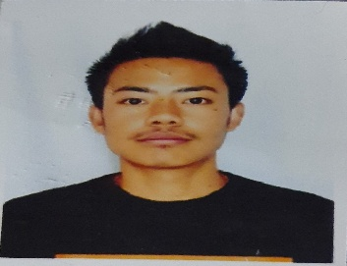**Sanjay Bomzon**

Rasdal Gaon, Mirik  
West Bengal  
Telephone: +918617440696   
E- mail Address: [tamangsanjay310@gmail.com](mailto:tamangsanjay310@gmail.com)

**Profile Summary**

* Bachelor in Commerce from Gyan Jyoti College, Siliguri, West Bengal.
* Ambitious and hard working fresher capable of applying technical skills for the betterment of the company.
* Effective communicator and can work efficiently under pressure.
* Looking forward to work in an environment that can boost overall learning.

**Education**

**Bachelor, Commerce** Graduated, July 2020Gyan Jyoti College Marks 55.29 %  
University of North Bengal Division 2  
Siliguri, West Bengal

**10+2** Graduated, July 2017Mirik Higher Secondary School Marks 82.80%  
West Bengal Board Division 1  
Mirik, West Bengal

**Extra- curricular experience**

* Captain of college football team.
* Participated in inter-college singing competition.
* Participated in inter- college volleyball competition.

**Strengths**

|  |  |  |  |  |
| --- | --- | --- | --- | --- |
| * Punctuality |  |  |  |  |
| * Adaptability |  |  |  |  |
| * Working under pressure |  |  |  |  |
| * Honesty |  |  |  |  |

**Computer Proficiency**

* Word 2010
* Excel 2010
* Power Point 2010

**Languages**

* Hindi
* English
* Nepali

**Personal Interests**

|  |  |
| --- | --- |
| * Sports |  |
| * Music |  |
| * Art |  |

**Personal Snippets**

Father’s Name: Mr. Anil Bomzon Marital Status: Single  
Birthday: July 29, 1997 Nationality: Indian  
Gender: Male