**CURRICULUM VITAE**

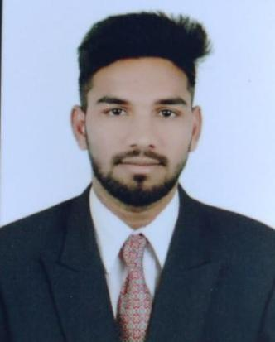

**SHAIK FAYAZ**

**CONTACT: +971 52 562 8372**

**EmaiIL:Shaik.iliyas3443@gmail.com**

**CAREER OBJECTIVE:**

Seeking a challenging career where I can work with dedication and professional Commitment for the development of the organization with an environment that would enable me to enrich knowledge and grow my skills.

**EDUCATIONAL QUALIFICATION:**

* Secondaryschool
* Intermediate

# WORK EXPERIENCE IN (DUBAI, UAE)

* Organization : WESTZONE SUPER MARKET LLC
* Position : SALES ASSISTANT
* Period : JULY 2021 to TILL NOW

# WORK EXPERIENCE IN (DUBAI, UAE)

* Organization : TOOL RIDE TECHINCAL LLC
* Position : STORE KEEPER
* Period : February 2020 to June 2021 (1 year 05 months)

# Responsibilities

* Maintain and develop good relationship with costumers thought personal contact or meetings or via telephone etc.
* Must act as a bridge between company and its current market future market

# SKILL ABILITIES OF PROJECT

* Territory planning and layout
* Organizational skills, multitasking and time-management.
* Problem solver, decision maker, honest, creative, assertive and accountable.

# PERSONAL INFORMATION

* Father’s Name : SHAIK FAREED
* Date of Birth : 12-12-2000
* Marital status : SINGLE
* Religion : ISLAM
* Nationality : INDIAN
* Passport No : S9230006
* Place of Issue : NIZAMABAD

**DECLARATION:**

**I** hereby certified that the above statements are true and correct either all my knowledge.