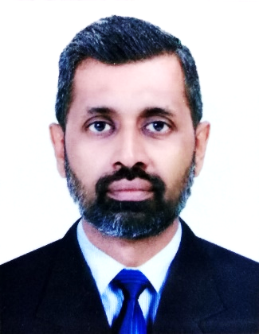

**Diganage sirimal**

**Manager**

**PROFILE**

Results-driven professional with a proven track record in sales management, leadership, and business development. Seeking a challenging managerial position in a dynamic organization where I can leverage my skills and expertise to drive revenue growth, foster customer satisfaction, and lead high-performing teams. Committed to delivering exceptional results through strategic planning, effective communication, and a customer-centric approach. Looking to contribute to the organization's success and drive sustainable business growth.

**WORK EXPERIENCE**

**Branch Manager**

Arpico Super Market - Sri Lanka

2018 – Present

Oversaw the overall operations of the branch, including sales, inventory, and customer service.

Developed and implemented sales strategies to drive revenue growth.

Managed and motivated a team of employees to achieve targets and deliver exceptional service.

Monitored and analyzed sales performance, market trends, and customer feedback.

**Assistant Manager**

Arpico Super Market - Sri Lanka

2017 - 2018

Assisted the store manager in daily operations and decision-making.

Supervised and trained staff to deliver excellent customer service.

Implemented strategies to optimize store layout and product placement.

Monitored and maintained proper inventory levels and stock rotation.

Conducted performance evaluations and provided feedback to team members.

**FMCG Executive**

Arpico Super Market - Sri Lanka

2011 - 2016

Managed a team of sales representatives and provided training and guidance.

Built and maintained strong relationships with key clients and suppliers.

Oversaw inventory management and ensured optimal stock levels.

**FMCG Incharge,** Arpico Super Market - Sri Lanka

2009 - 2010

**FMCG Supervisor,** Arpico Super Market - Sri Lanka

2006 - 2008

**Office Clerk,** Arpico Super Market - Sri Lanka

2003 - 2005

**Chief Cashier,** Arpico Super Market - Sri Lanka

2002 - 2003



**Cashier,** Arpico Super Market - Sri Lanka

2001 - 2002

**Store Keeper,** Keels Super Market - Sri Lanka

1997 - 1998

**CCTV Operator,** Keels Super Market - Sri Lanka

1996 - 1997

**PROFESSIONAL QUALIFICATIONS**

**Bachelor of Arts**

University of Ruhuna – Sri Lanka

2002

**ACADEMIC QUALIFICATIONS**

**GCE Advanced Level Examination**

Department of Education - Sri Lanka

1995

**REFERENCES**

**Mr.Oshan Pieris**

Head of operation - Arpico super market

310,Highlevel road, Maharagama, Sri lanka

+ 94 77 776 5433 / +94 77 133 3221

oshan.peiris@arpico.com

**Mr.Lahiru Jayasekara**

Reagonal Manager - Arpico super market

310,Highlevel road, Maharagama, Sri lanka

+ 94 77 241 5494 / +94 77 051 9541

lahiruj@arpico.com

I do hereby certify that the above particular given by me are true & accurate to the best of my knowledge. If I'm offered an opportunity to serve in your esteemed organization, I can assure you that I shall always perform my duties with commitment & loyalty.

Diganage sirimal

**CONTACT INFO**

**PHONE**

+971551292559

**WHATSAPP**

+94 77 308 0858

**MAIL**

sirimald694@gmail.com

**LOCATION**

Al sathuwa,

MSM building, 3rd floor,

Room number 302/03.

**IT SKILLS**

MS Word

MS Excel

MS Power Point

IT Literacy

**SKILLS**

Sales Management

Leadership

Staff Training and Development

Inventory Report Generation

Customer Relations

Market Analysis

Complex Problem Solving

Innovation

Project Management

Business Development

Effective Marketing

Compassion

Flexibility

Creativity

**LANGUAGES**

**ENGLISH**

**SINHALA**

**PERSONAL INFORMATION**

**• NAME IN FULL**

Diganage sirimal

**• DATE OF BIRTH**

13.06.1976

**• GENDER**

Male

**• CIVIL STATUS**

Married

**• NATIONALITY**

Sri Lankan

**• PASSPORT NUMBER**

N10691573

**• NIC NUMBER**

761651617V

**• DRIVING LICENCE NUMBER**

B1896091