CURRICULUM VITAE

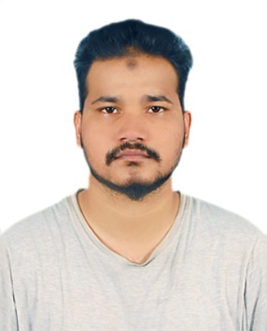

MOHAMMED SUBHAN

E-mail: isubhanmd@gmail.com

Mobile No: +971-507904055

Place: ABU DHABI, U.A.E.

Presently available on Visit visa

Position: Sales Executive / Customer Service

CAREER OBJECTIVE:

To pursue a challenging career and to be a part of an esteemed organization that gives scope to enhance my knowledge, skills with dedication and hard work.

EDUCATIONAL QUALIFICATIONS:

* DEGREE B.COM COMPUTERS KAKATIYA UNIVERSITY.
* Intermediate NARAYNA JR College.
* High School Studies from NATIONAL HIGH SCHOOL, GOLCONDA, Hyderabad.

WORK EXPERIENCE:

* Worked as a merchandiser sales man for 7 years. In INDIA
* ORGANIZATION; **Clarks**, **Steve Madden, and United colours of Benetton**

ROLES & RESPONSIBILITIES:

* Provided excellent customer service to all customers.
* Operated cash and card register, handling daily basis.
* Worked closely with department managers assisting them with daily tasks.
* Established and maintained positive and constructive client relationships.
* Helped customers with all related needs.
* Maintained stock and appearance of the store department.
* Maintained work area and followed sales floor standards to enhance sales.
* Prioritizes and plans workload of data entry tasks in compliance with schedules, deadlines, protocol and policy.

KEY SKILLS:

* Strong Interpersonal, analytical and communication skills
* Written communication skills and willingness to learn.
* Ability to deal with people diplomatically.
* Adaptable to job challenges and changes.

PERSONAL PROFILE:

|  |  |
| --- | --- |
| Name | : MOHAMMED SUBHAN |
| Father Name | : MOHAMMED GHOUSE PASHA |
| Date of Birth | : 31-07-1999 |

Passport Number : T6113232

Nationality : Indian - Single

Gender : Male

Languages known : English, Urdu, Hindi, Telugu.

Residence Address : ABU DHABI , UAE.

DECLARATION:

Here by, I confirm that the above mentioned information is true as per my knowledge.

Place: ABU DHABI

Date: MOHAMMED SUBHAN